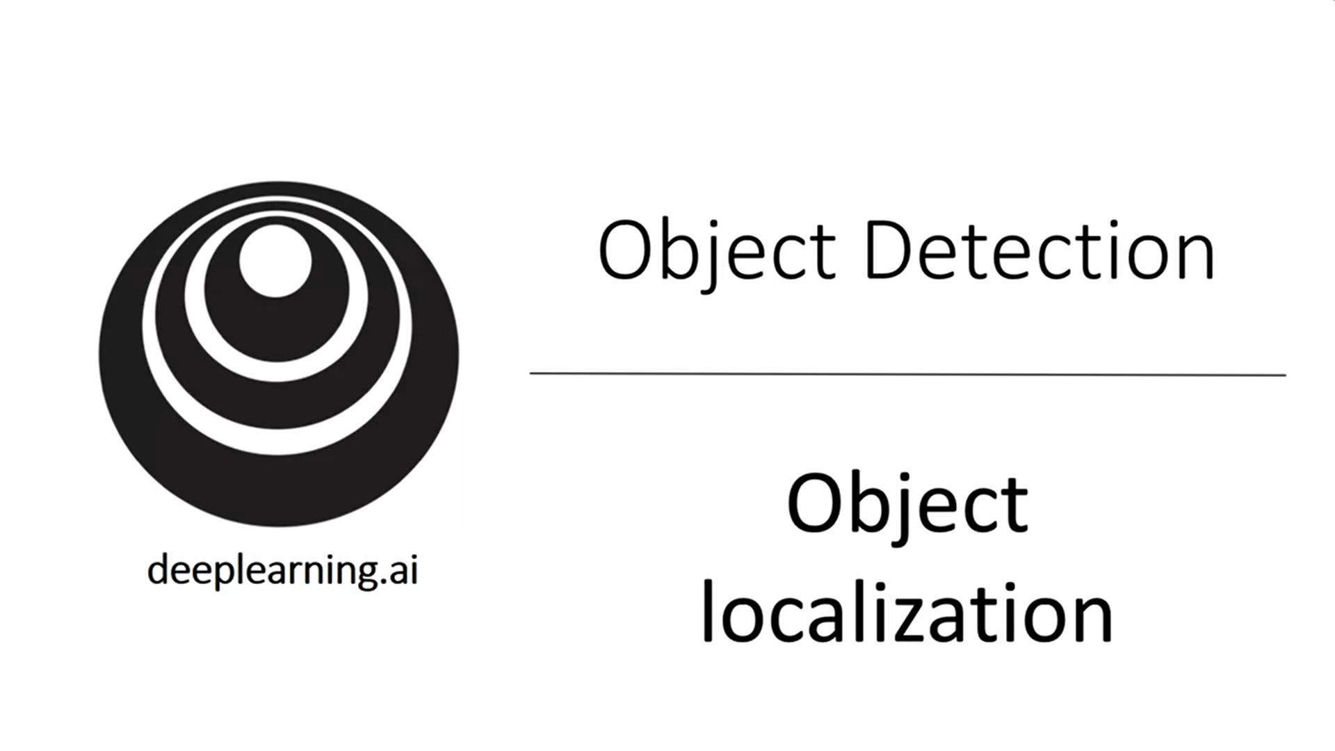

This week we will learn about object detection, one of the areas of computer vision that is currently exploding and works so much better than a few years back.

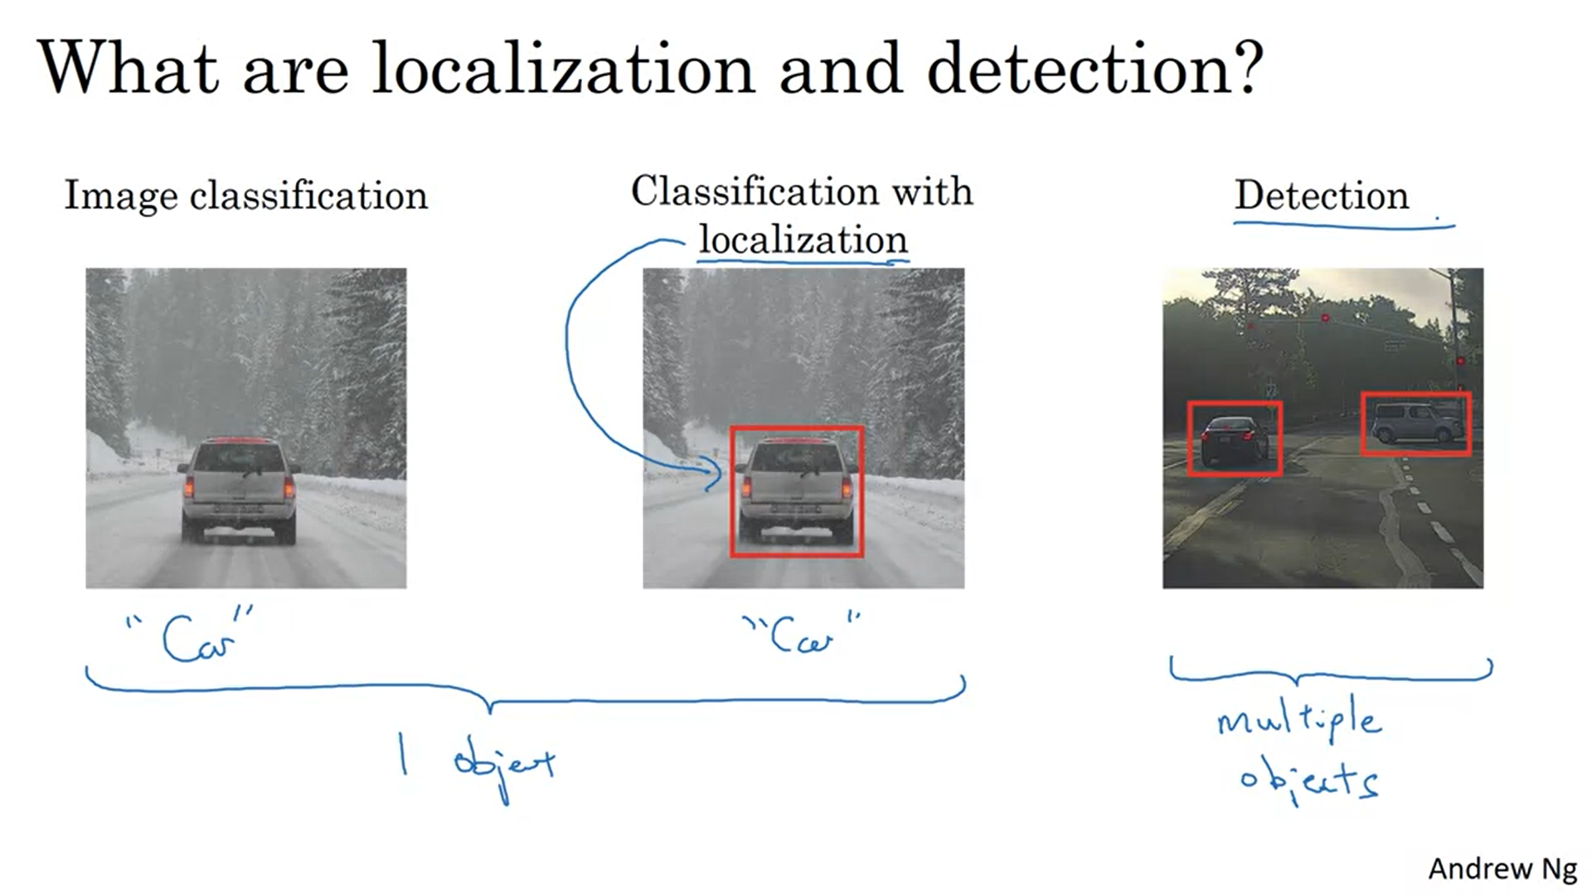

Classification with localization: detect car (1 object) and draw bounding box.

Some ideas will transfer from left to right

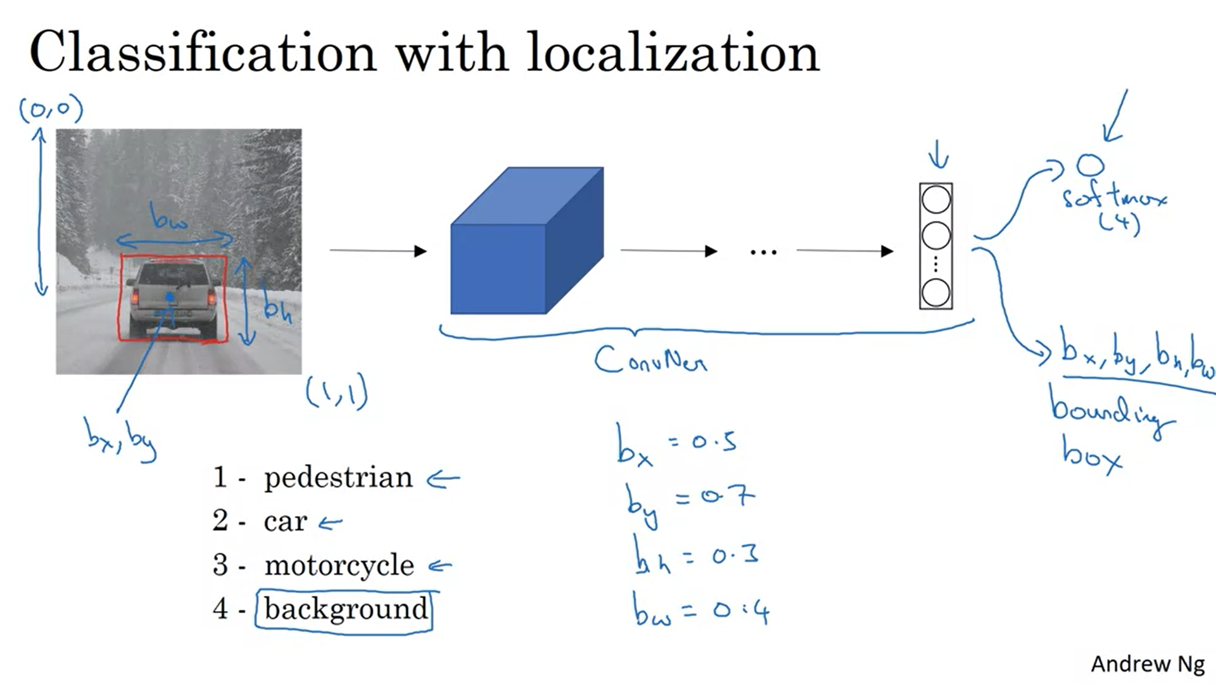

Example: autonomous driving; 4 different objects to detect

Add 4 additional numbers to the output to parameterize the bounding box. This has to be included in the training set.

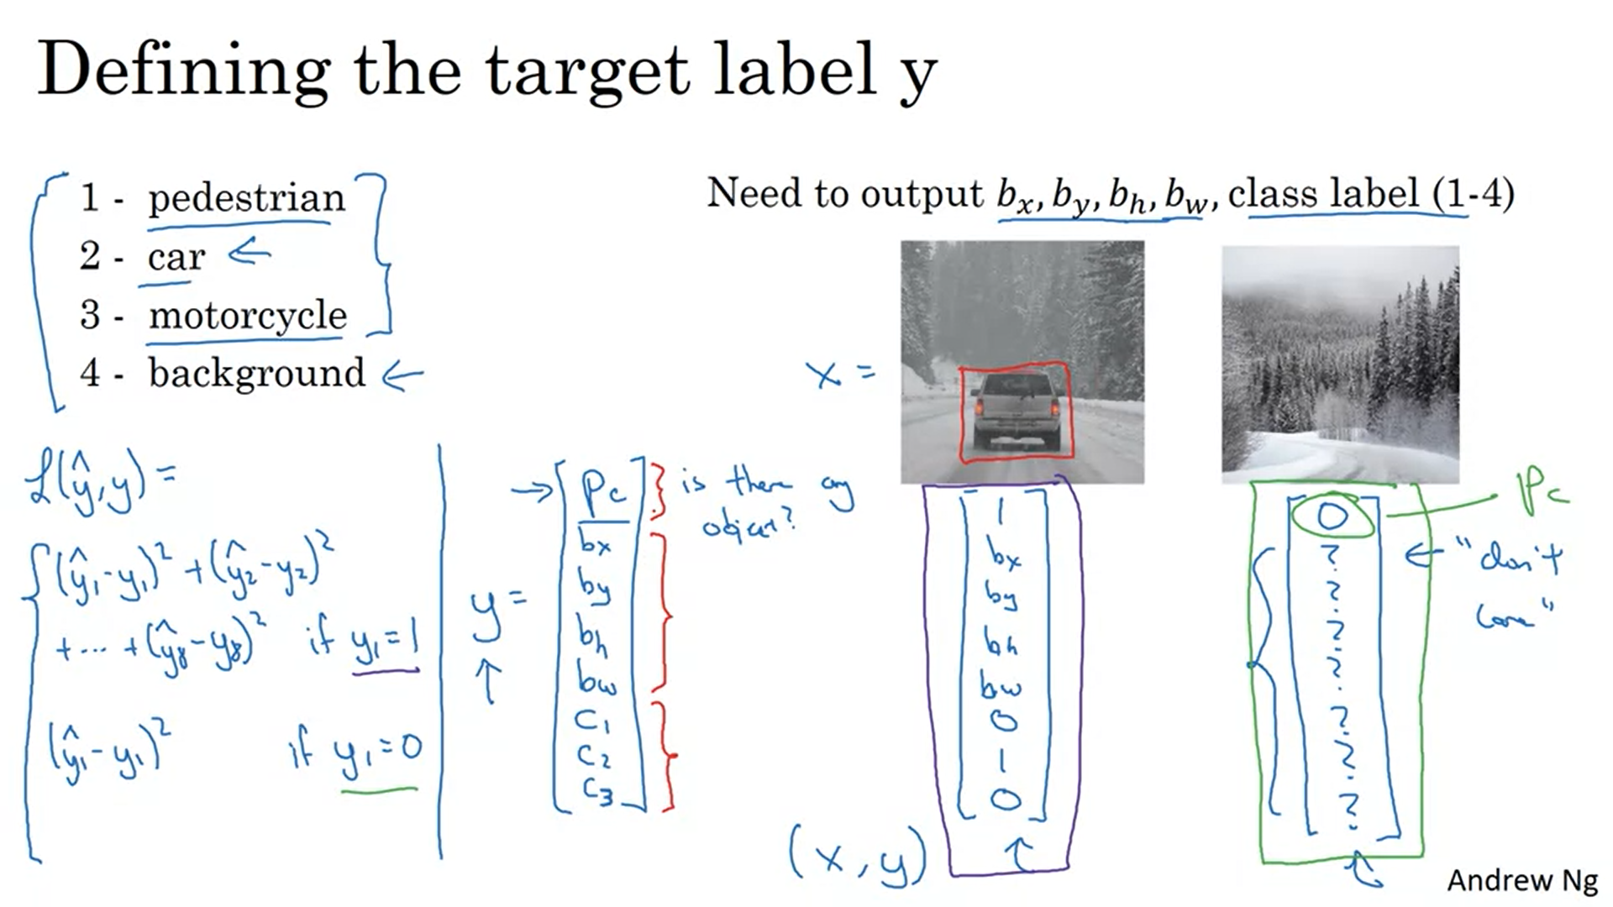

P_c: Probability that one of the classes 1-3 is in the image (not the background class)

C_1, c_2, c_3 tells whether the object is a pedestrian, car or motorcycle. Remember that in object localization we have only one object in the image. Only one of the c’s will be 1.

? are don’t cares.

Loss function (for one training example) is a sum over the squared errors of all the elements in the label.

Squared error is a simplification here. In practice you can use log-likelihood loss for the classes c, squared error for the bounding box coordinate, logistic regression loss for the probability p_c.

The idea of having neural networks output real numbers to detect where things are is quite a powerful idea.

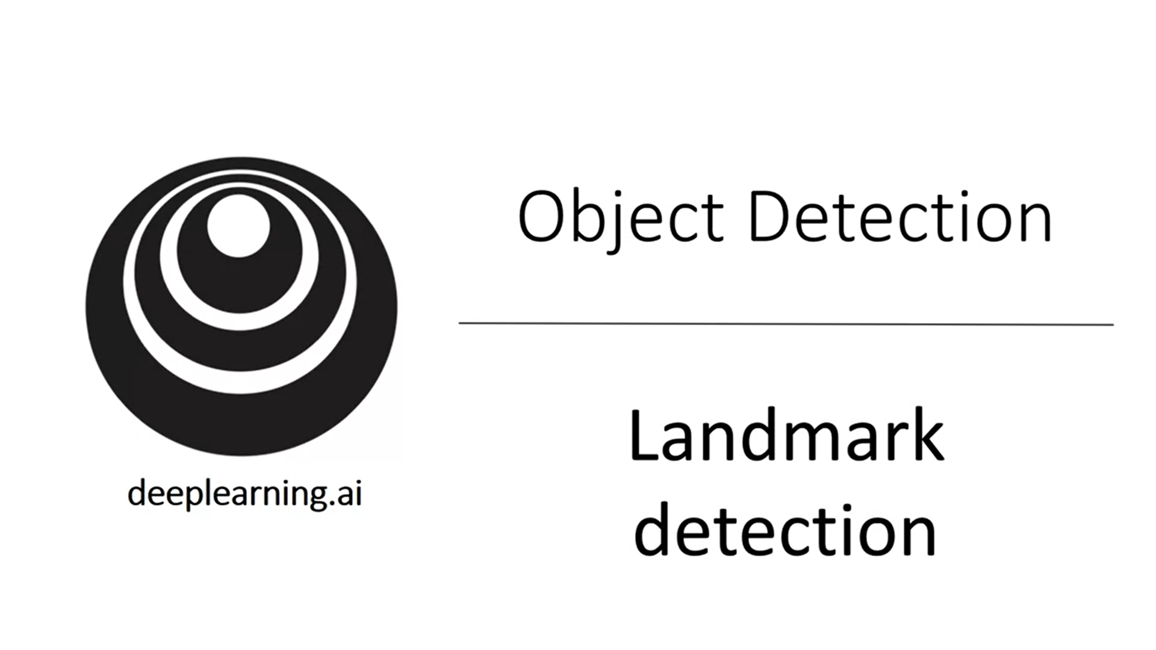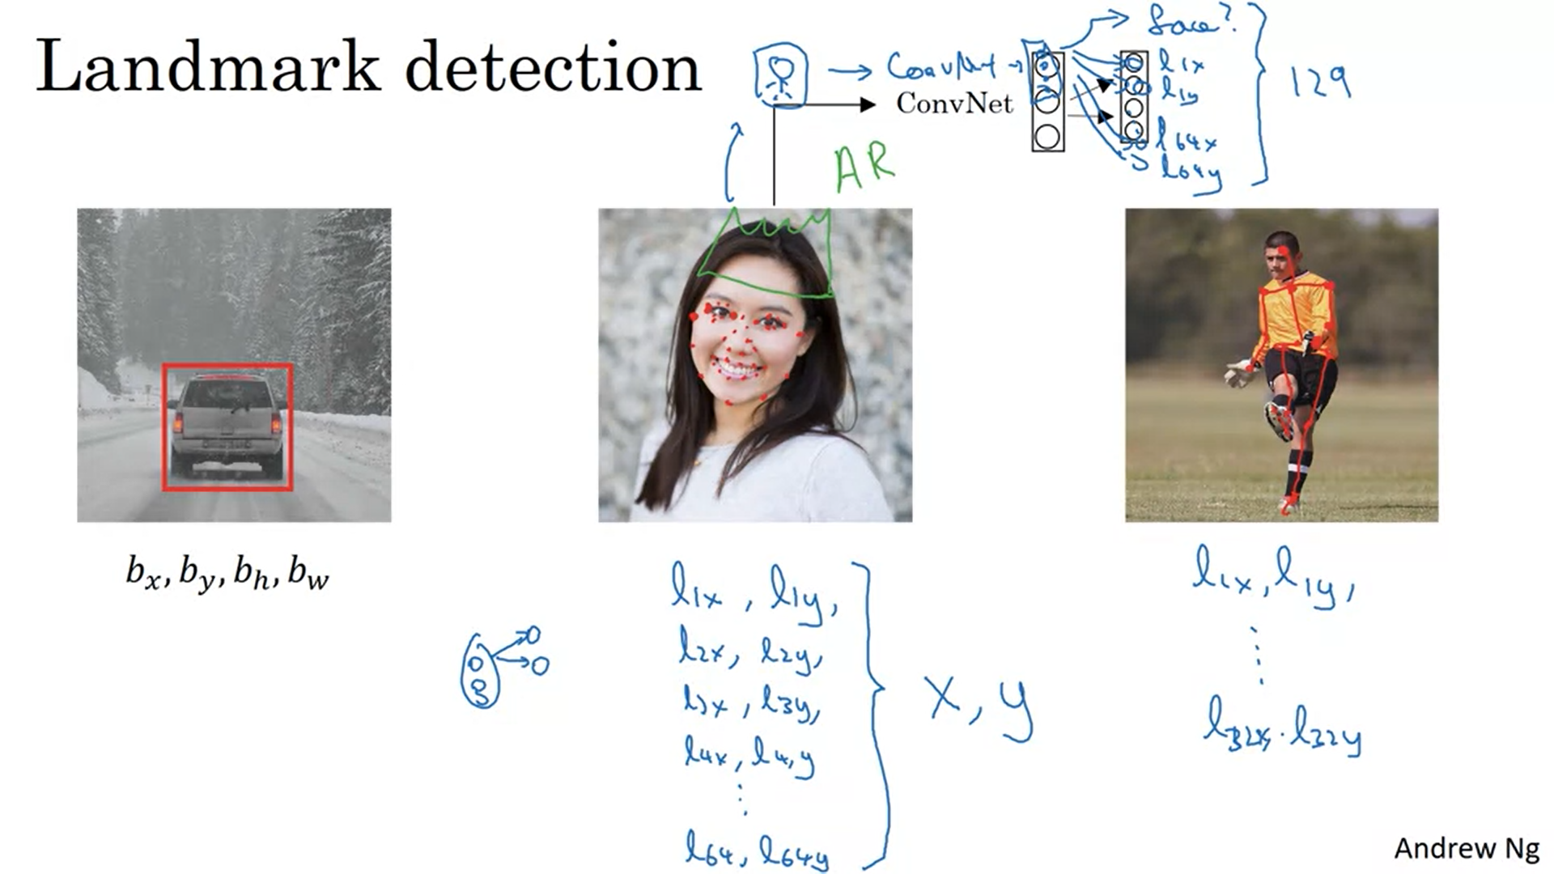

Corner coordinates of the eye. Or even more landmarks on the face -> use the coordinates to create the label (129 output units; 1 for whether there is a face or not). This is a key building block for entertainment ar filters (draw something on the face of a person).

Another example is people pose detection.

The labels must be consistent across different images -> the same landmark has to have the same position in the label.

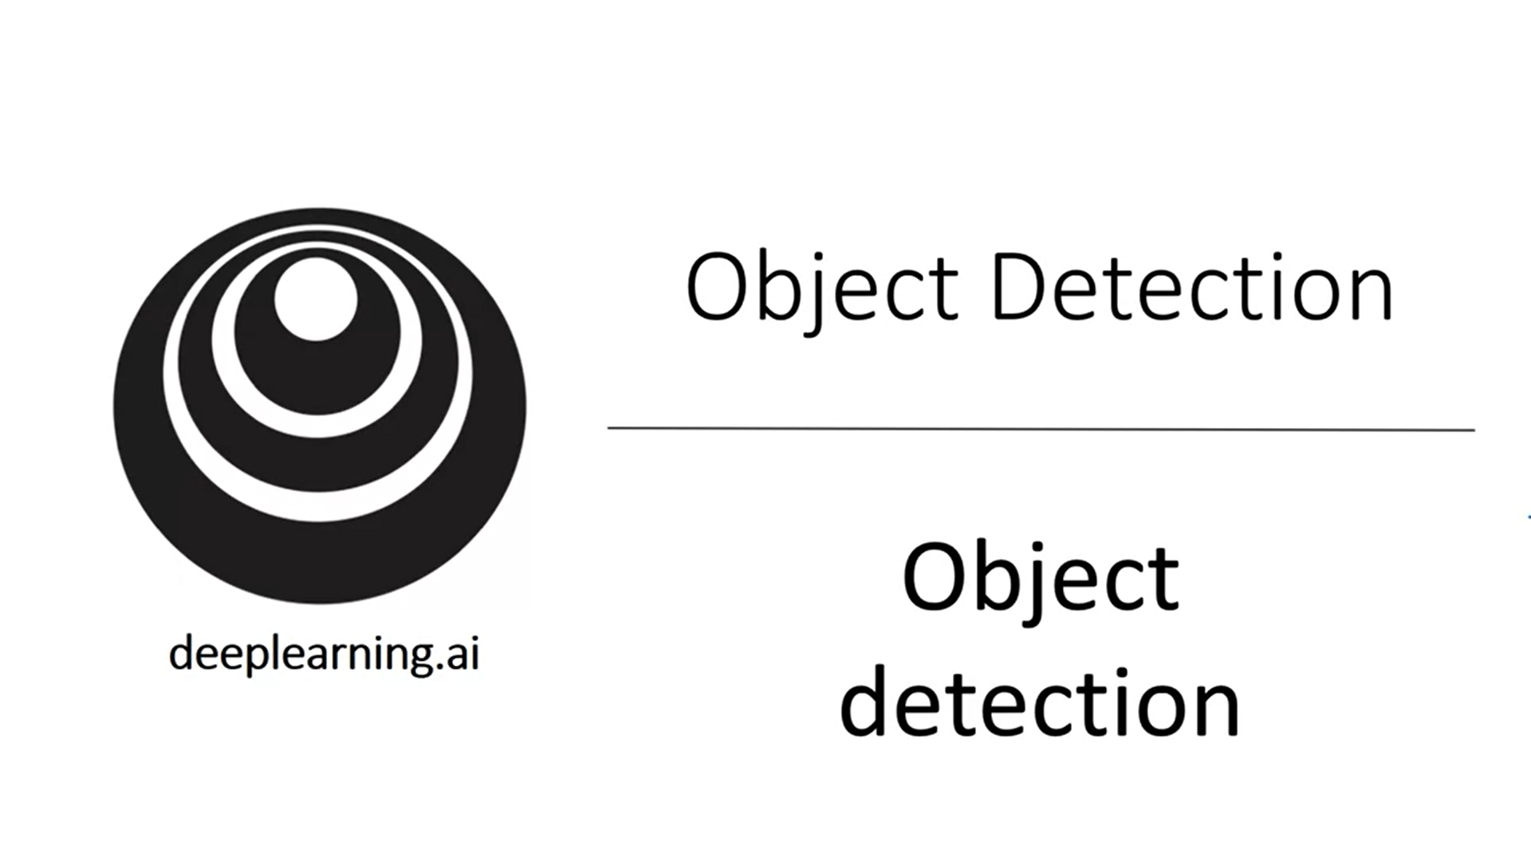

Now let’s take the building blocks we have seen so far and start building up to object detection.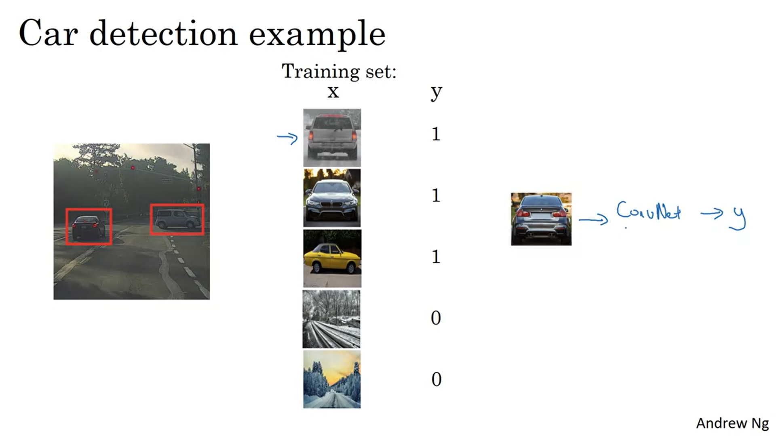

Sliding windows detection algorithm.

Example: car detection. Training set consists of closely cropped images. Train a convnet that inputs a closely cropped image and outputs y (car or not).

Then use sliding windows to get input for this convnet.

Start with a certain size for the sliding window. Start on the top left of the image and shift the sliding window by a bit and pass all these cropped images to the convnet.

Then increase the size of the sliding window by a bit and run the same process again.

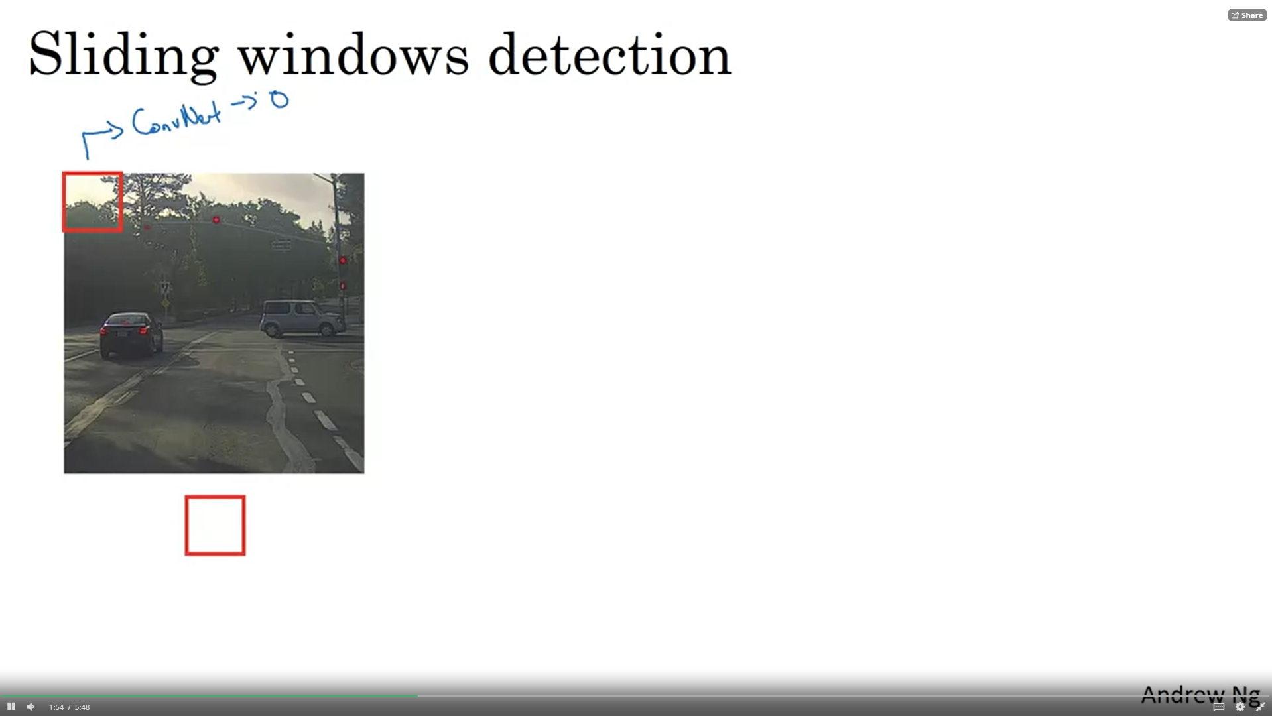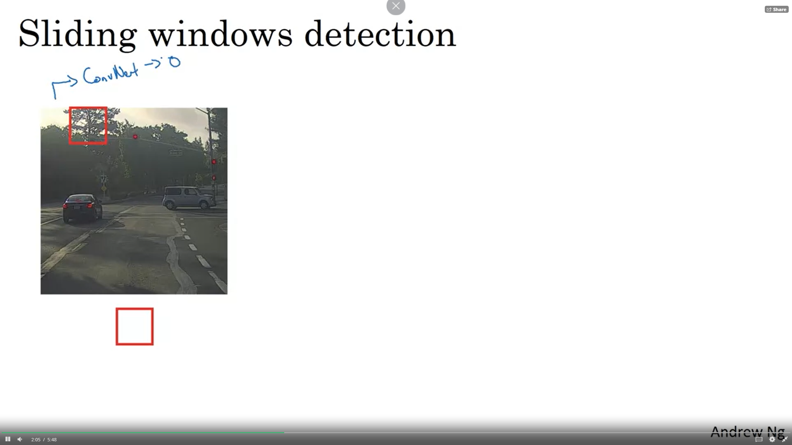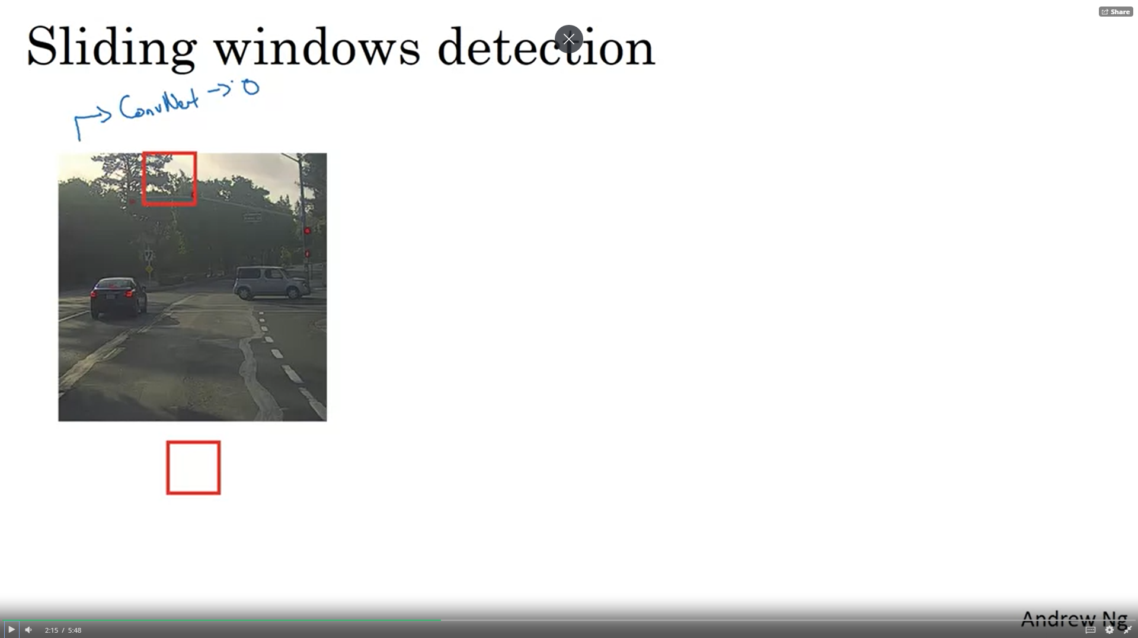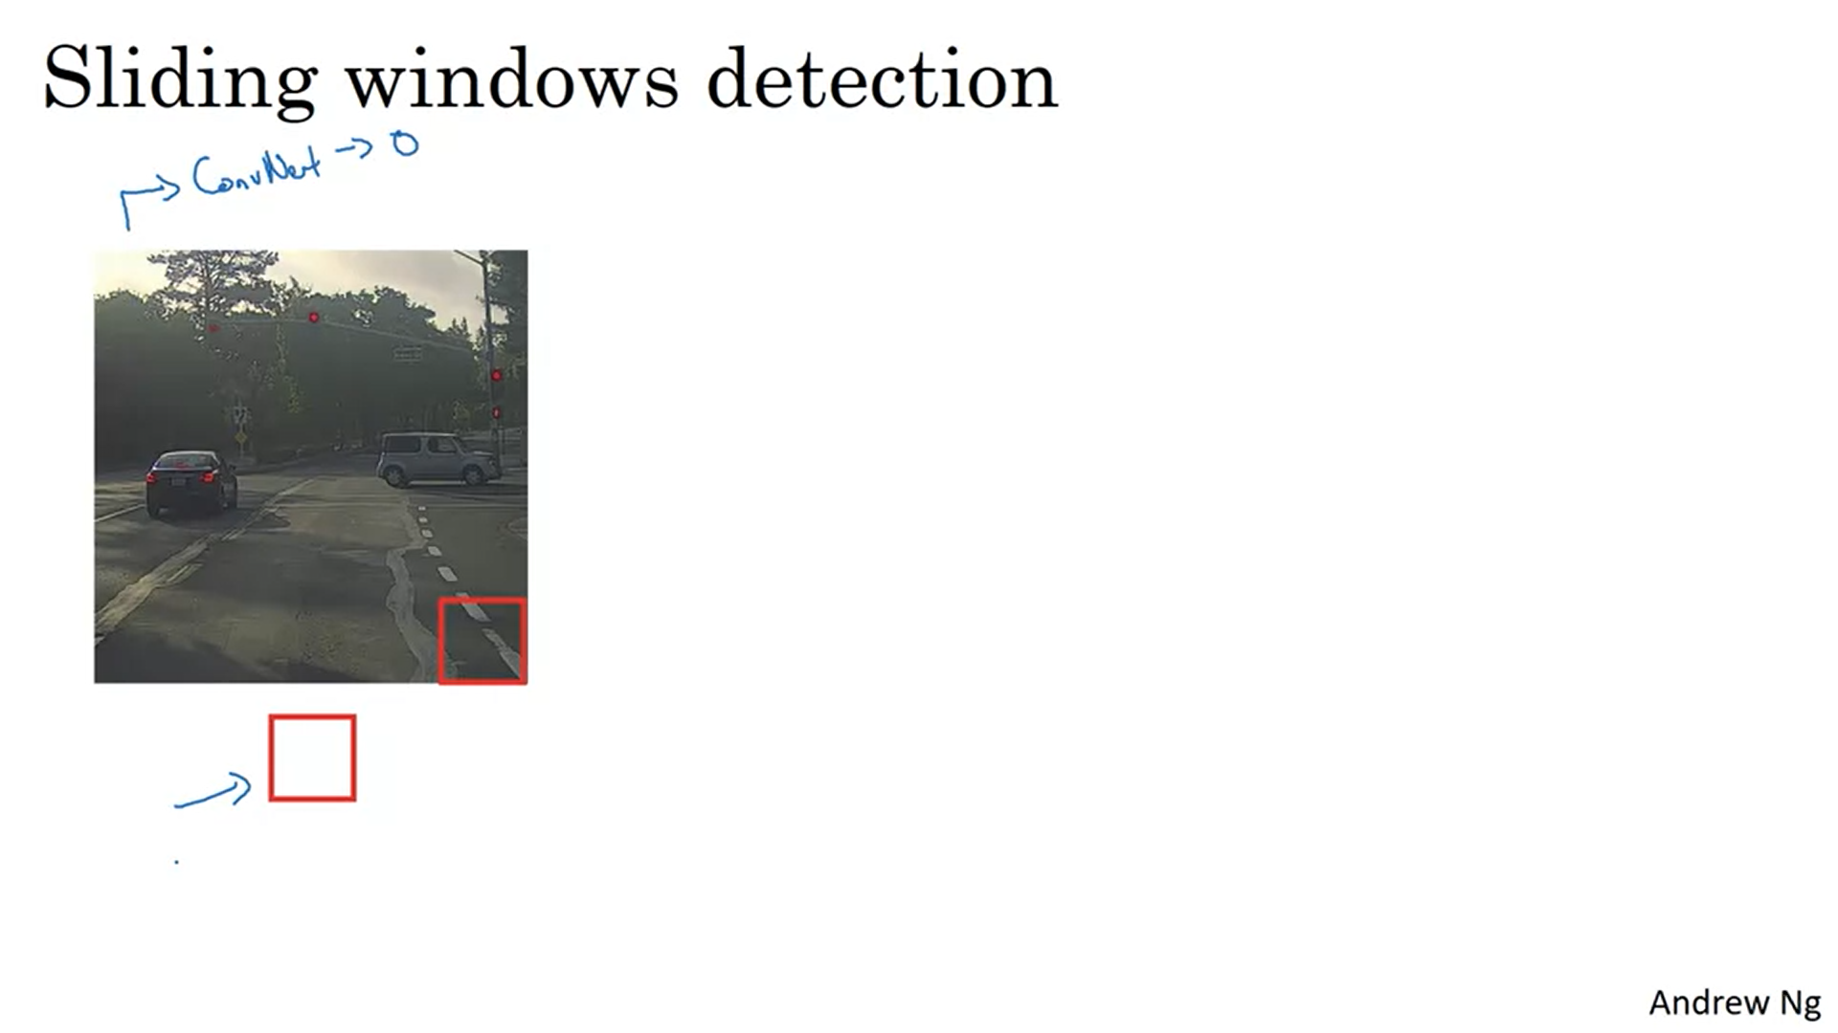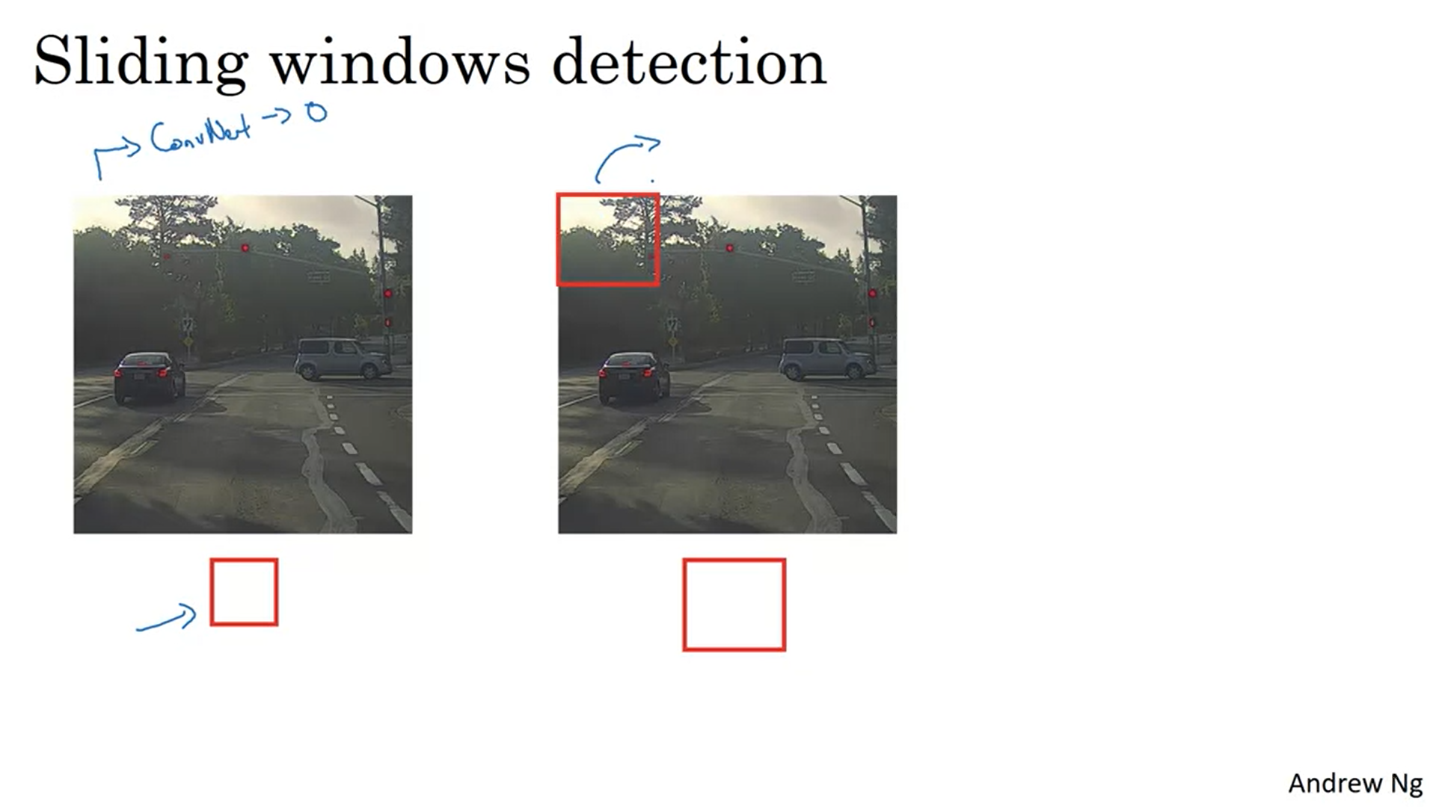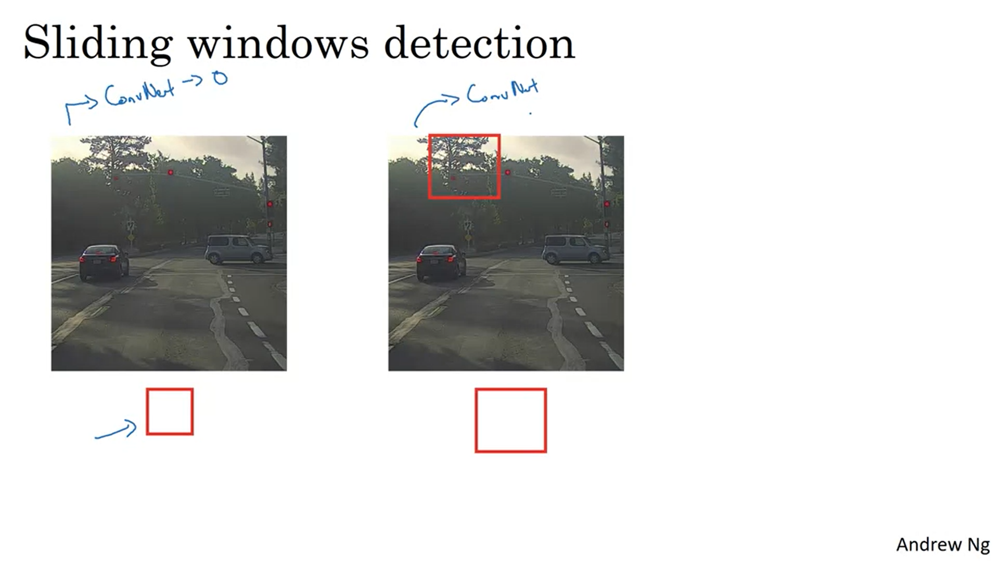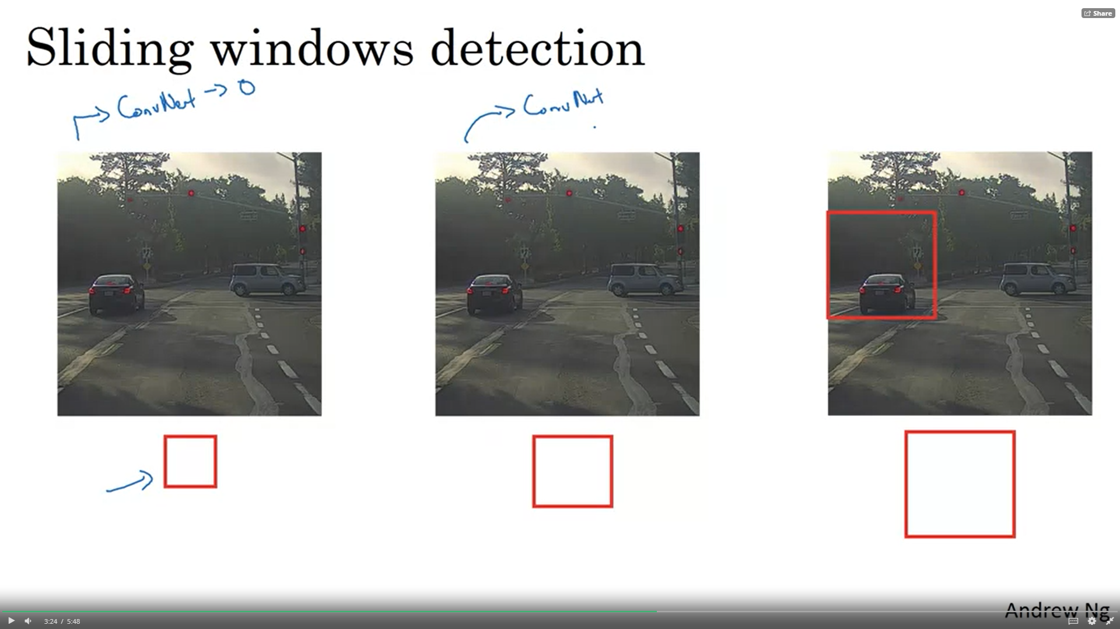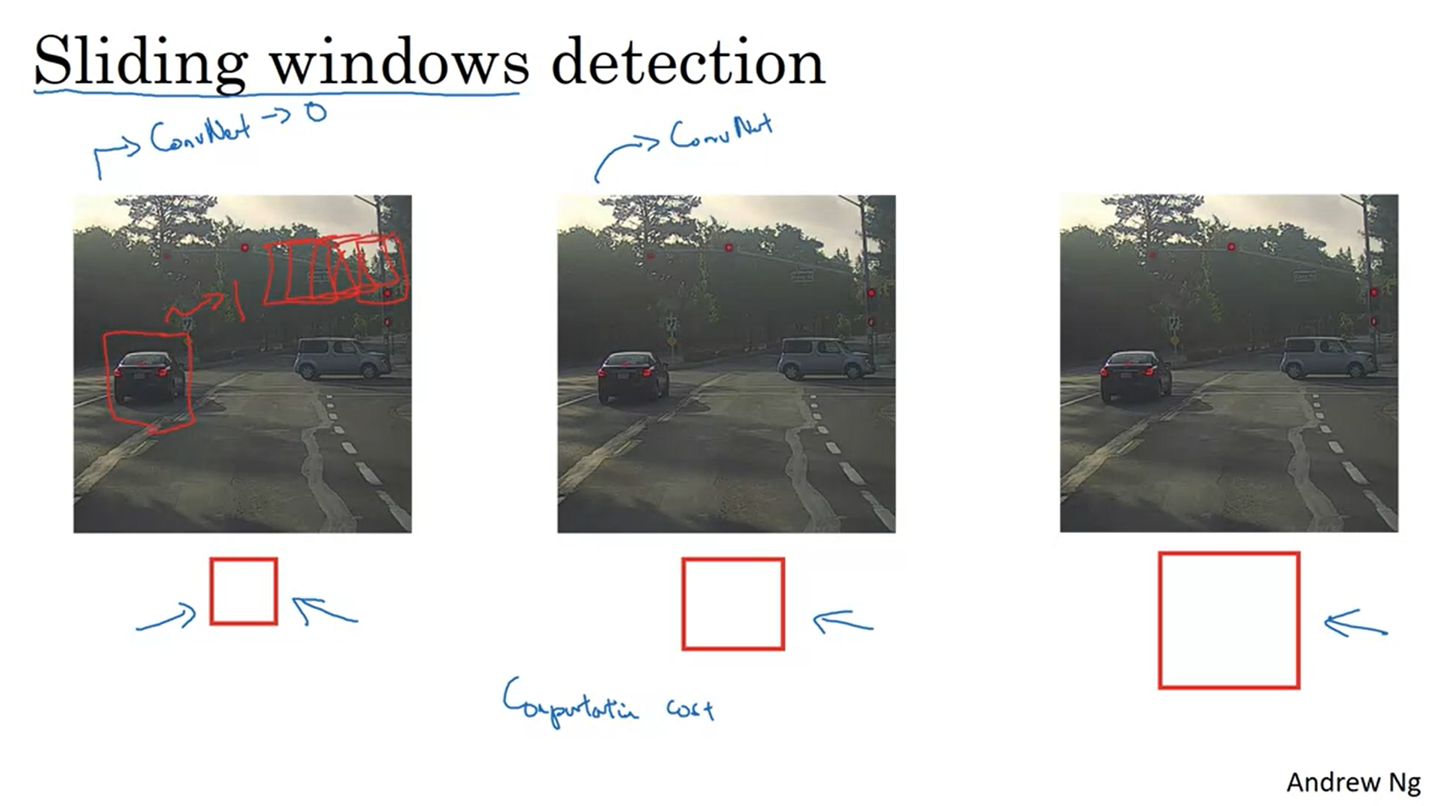

The hope is that for some window, the convnet will output 1 for the region where the car is.

A huge disadvantage of sliding windows is the computational cost! This could be reduced by a huge stride but without fine granularity you might hurt performance.

Sliding windows detection was already used before neural networks and then it ran ok because the computational cost of the used algorithms was lower. With convnets this is much more expensive and infeasibly slow.

Fortunately, there is a pretty good solution. We can implement the sliding window detector convolutionally.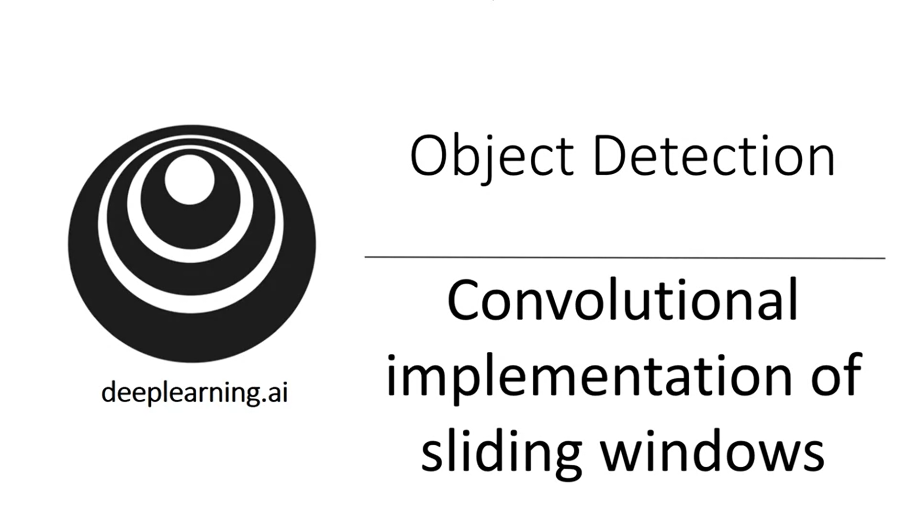

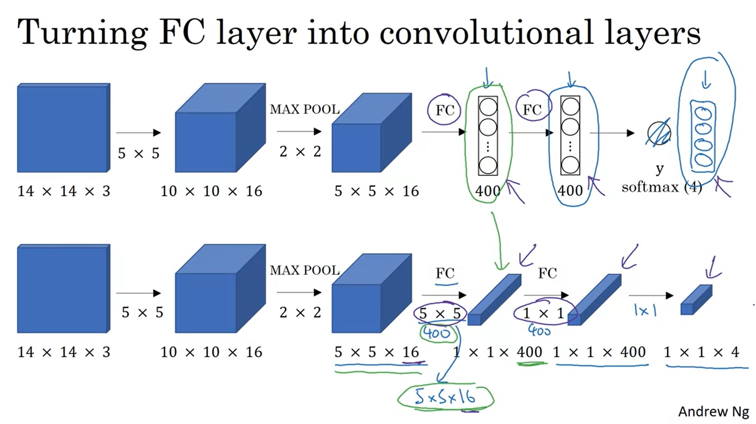

Let’s first see how we can turn fc layers into convolutional layers.

For illustrative purposes we take a small 14x14x3 image. Start with a convnet architecture with softmax output layer. We want to replace the FC layers by conv layers now.

Filter size is as big as input volume size. Take 400 of such filters to create 400 nodes. Mathematically this is the same as a FC layer.

For the next layer implement 400 1x1 convolutions. Finally implement 1x1 convolution with softmax activation.

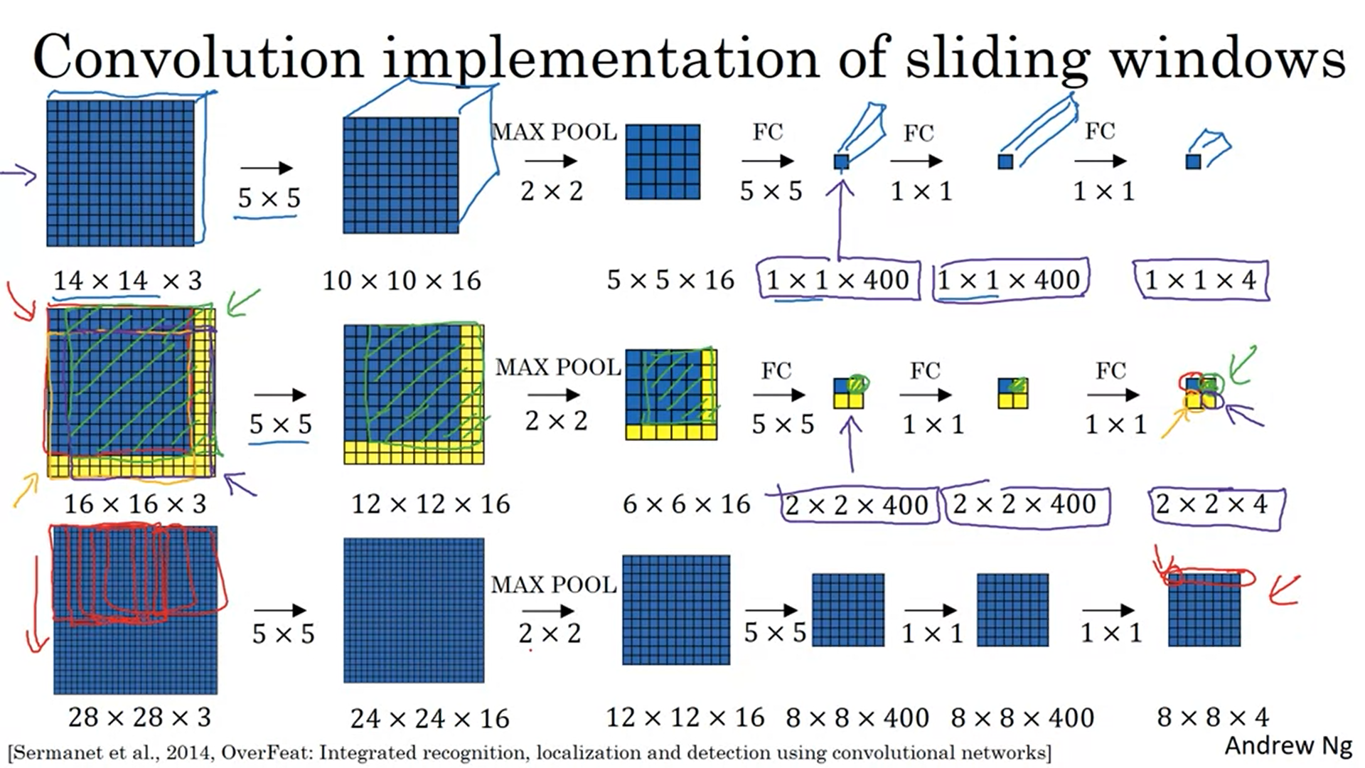

Now let’s see how we can have a convolutional implementation of sliding window detection.

Again, we use small images for simplification. Also, we just draw the “front face” of the volumes for simplification.

Test set image is 16x16x3. In the original algorithm we would want to first run the red window through a convnet, then the green window, then the orange window, then the purple window -> we would have to calculate 4 convnet outputs. But it turns out a lot of the computation is duplicate. The convolutional implementation addresses this issue to share computation.

Just take the whole image and run it through the convnet. Instead of a 1x1x400 volume you will get a 2x2x400 volume. You will be left with a 2x2x4 volume. It turns out that each of the subsets of the final output is the result of the different windows you started with.

Let’s look at the green example to verify this.

As a result, instead of running forward prop on 4 subsets of the input image, we combine all 4 in 1 forward prop and combine a lot of the computation done (for all regions that are common between the slided windows).

Bottom row shows an example with a bit bigger input image. Max pooling of 2 corresponds to a sliding window with a stride of 2.

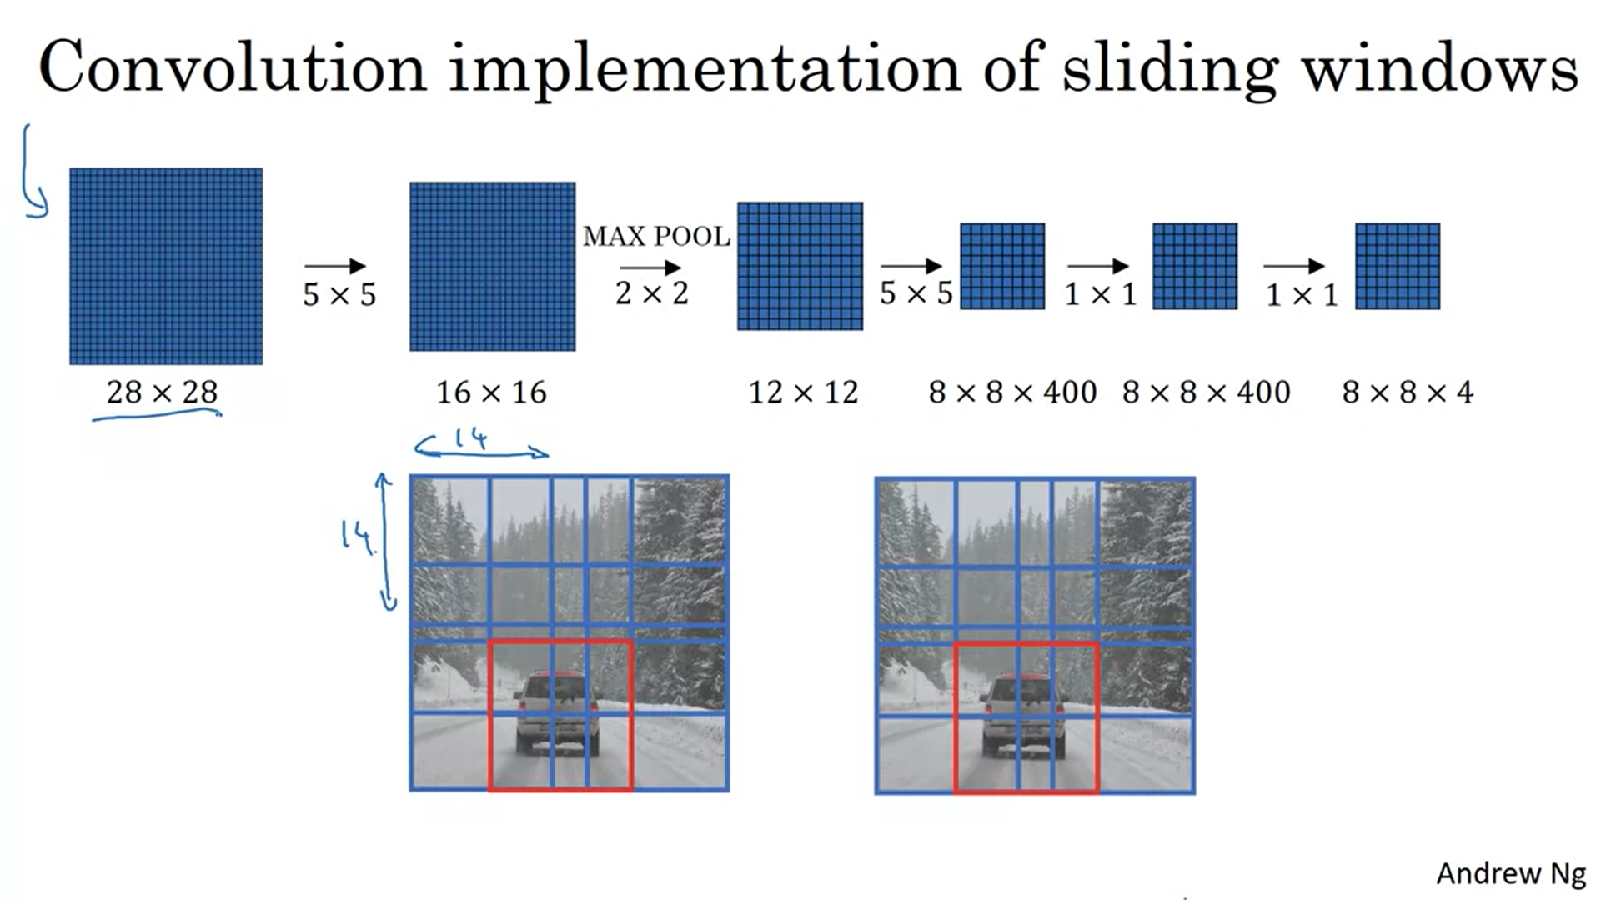

With the convolutional implementation we do not need sequential windows but do everything at the same time. This makes the whole thing much more efficient. However, there is still a weakness: the position of the bounding box is not very accurate (in the sense of adapted to the object).

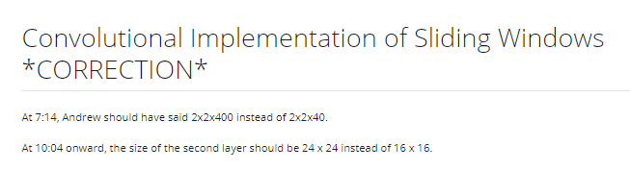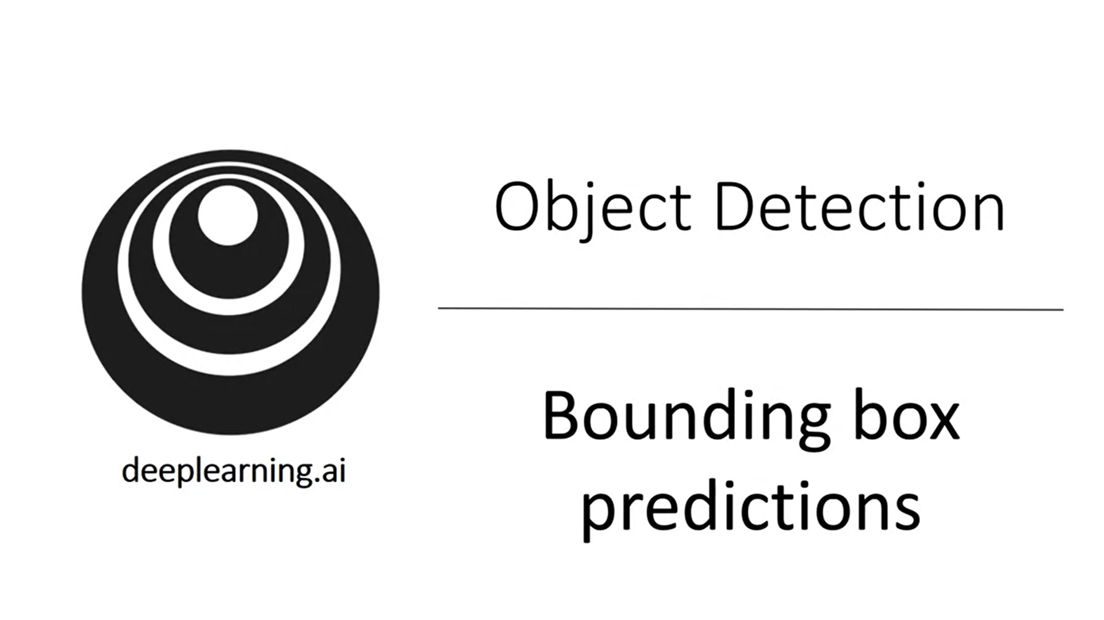

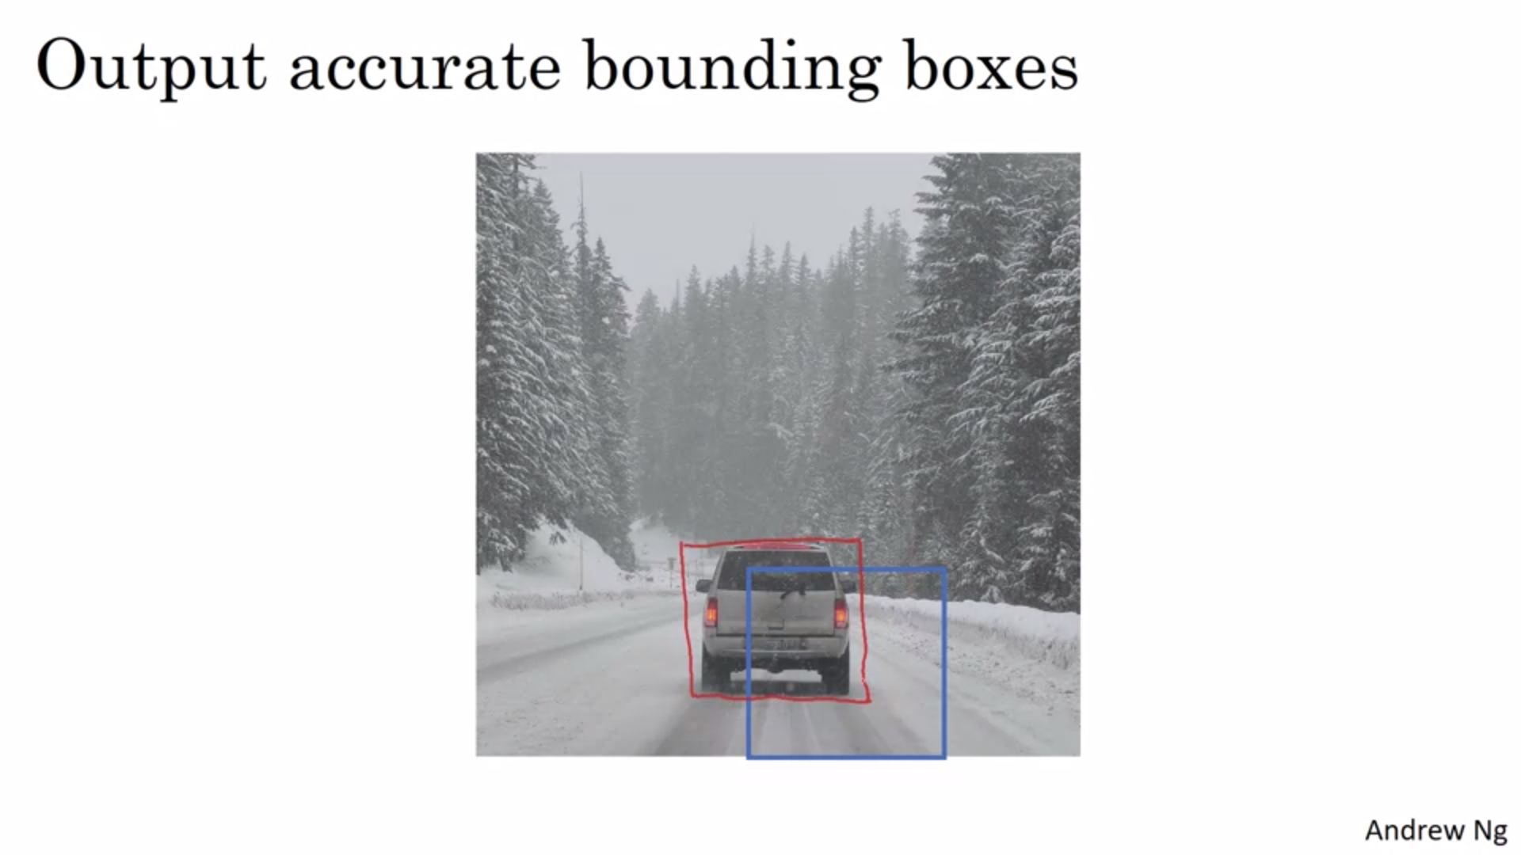

With sliding windows you may never really hit the right bounding box. Also, maybe the bounding box is not completely squared.

How can we output more accurate bounding boxes?

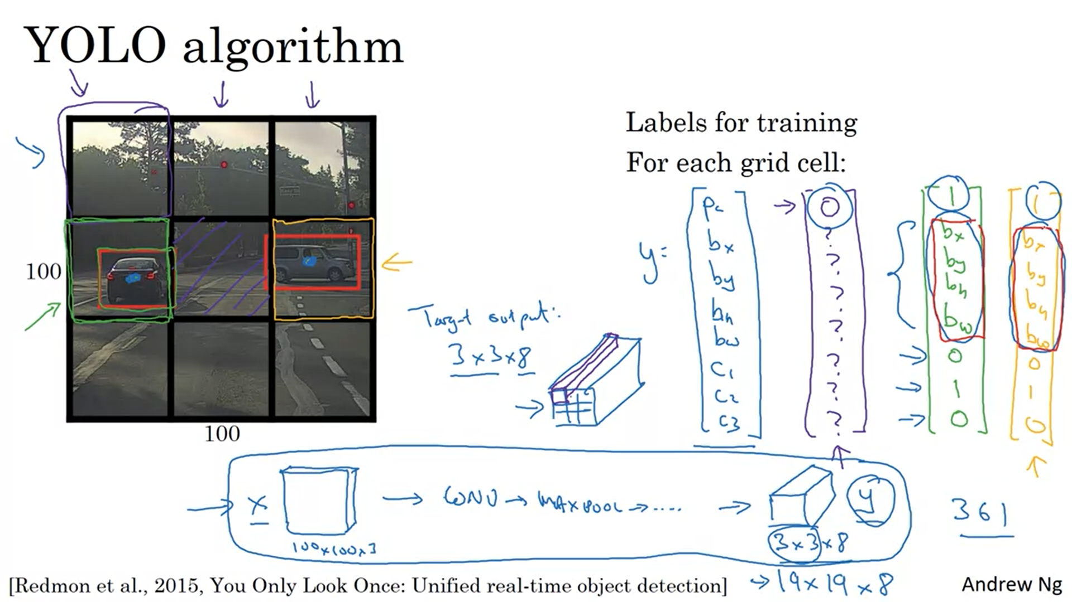

YOLO: You Only Look Once.

Place down a grid on the image. For simplification we only use a 3x3 grid but in reality you would use a finer grid, maybe 19x19.

The basic idea is to take the image classification & object localization algorithm and apply it to each cell of the grid.

For each of the nine grid cells you specify a label y (similar to before).

The label vector for the upper left grid cell is the purple one. The label vector for the left mid cell is the green one.

The YOLO algorithm assigns the object to the grid cell that contains the midpoint.

The target output is a 3x3x8 volume. In practice it could be a 19x19x8 volume (more fine-grained).

The algorithm will then output precise bounding boxes.

The object will only be assigned to one cell. With a more fine-grained grid the chance of two objects appearing in the same cell is lower.

This is a lot like the image classification and object localization algorithm. But this is a convolutional implementation (you are not running this algorithm 9 times, this is just one convnet with a lot of shared computation).

This is very fast and works even for real-time object detection.

There is one last detail: how to encode the bounding boxes?

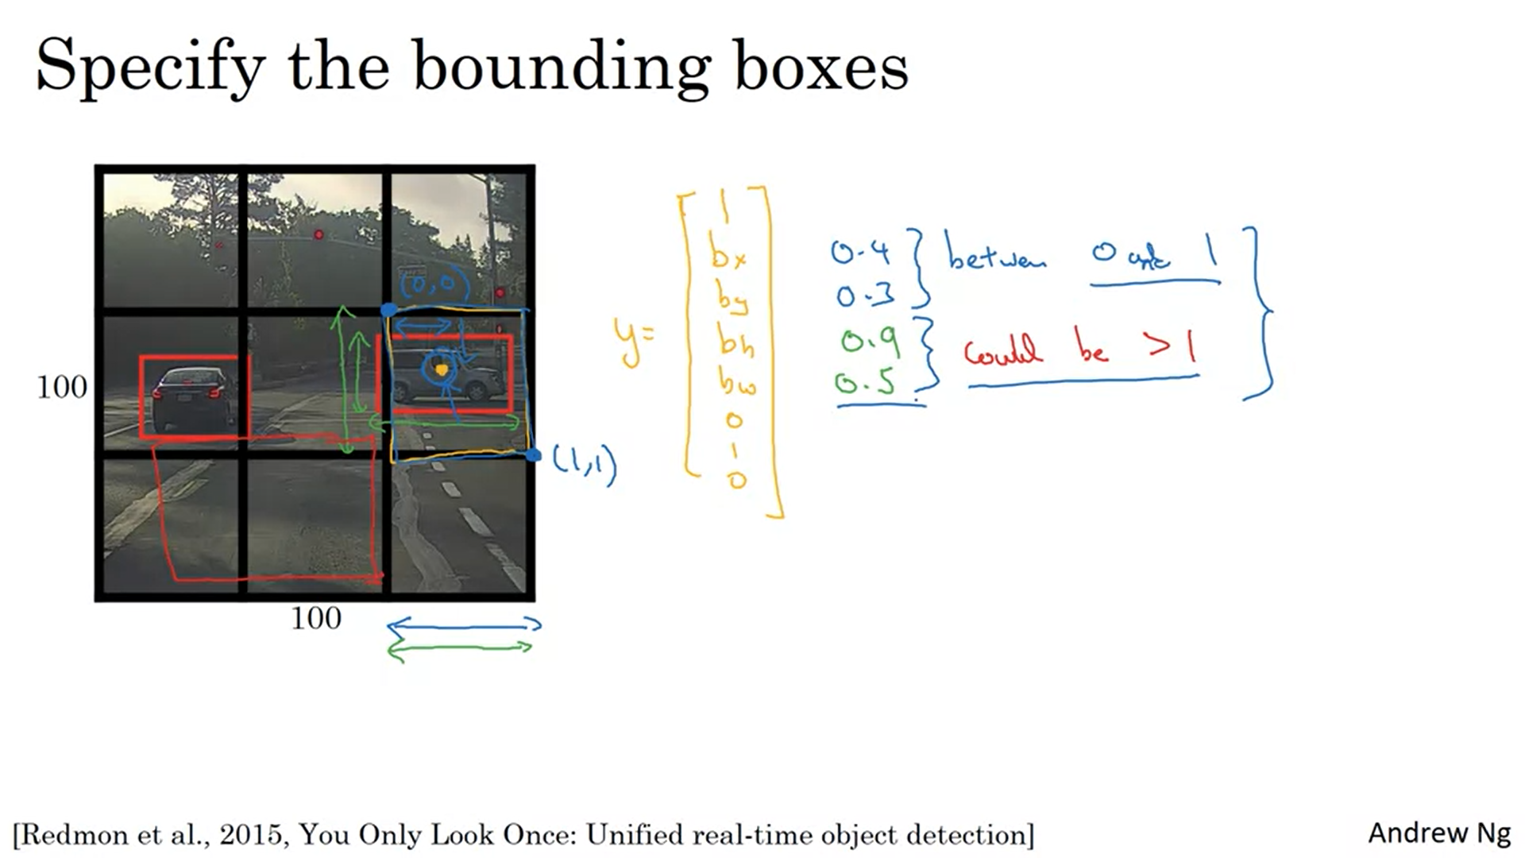

Example: car on the right.

Upper left point of the cell is (0,0) and lower right point is (1,1). X is the horizontal axis. Width is 90% of the cell -> 0.9. All these values are specified relative to the grid cell.

There are some more complicated parameterizations that work a bit better (involving sigmoid and exponential function to make sure values are between 0 and 1 and non-negative respectively).

In the next videos we will look at some more ideas that make this algorithm even better.

The YOLO paper is quite hard to read.

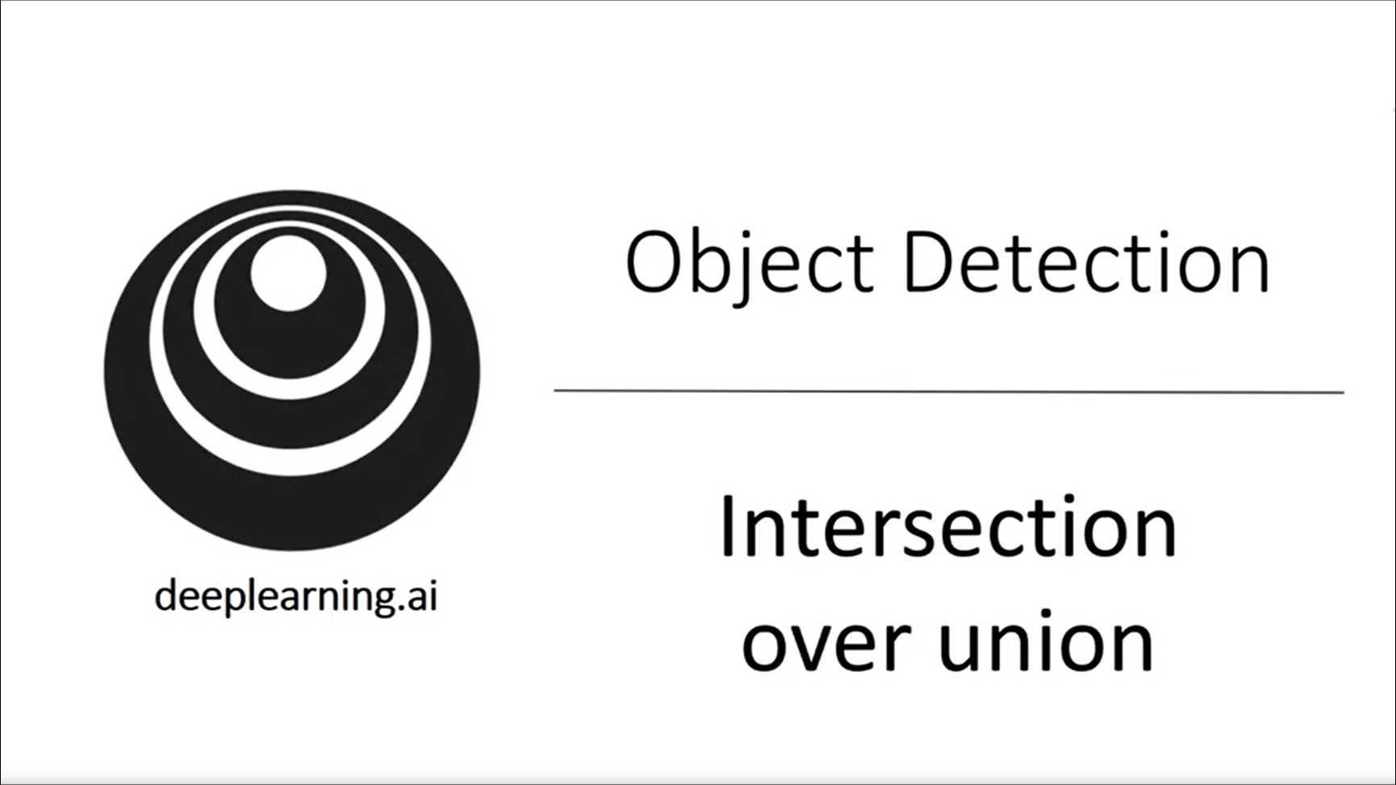

How to tell whether my object detection algorithm is working well? Intersection over union is used for evaluation but also for the algorithm to work even better.

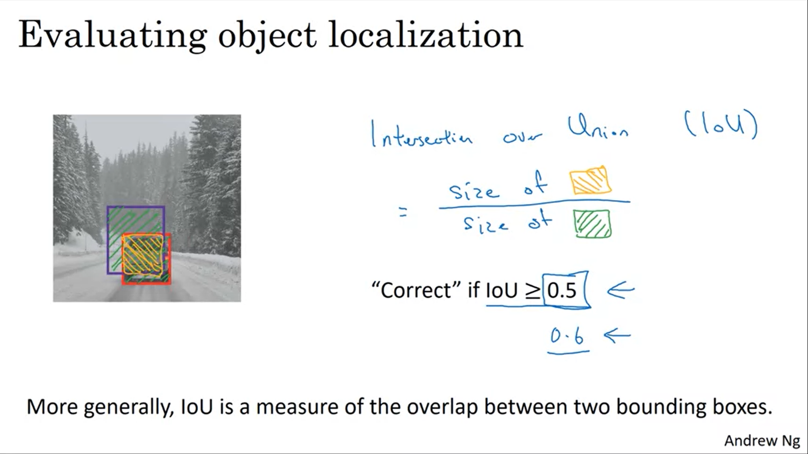

Is the purple bounding box a good outcome or not?

Union is the whole green area. Intersection is the orange area.

The higher the IoU, the more accurate the bounding box. 0.5 is a human-chosen convention (without theoretical reason).

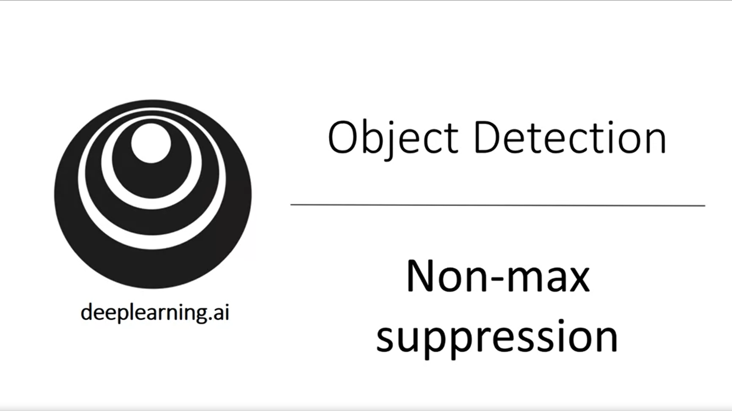

This is a tool that you can use to make the outputs of YOLO even better.

One of the problems of object detection is that the algorithm might find multiple detections of the same object (rather than just once).

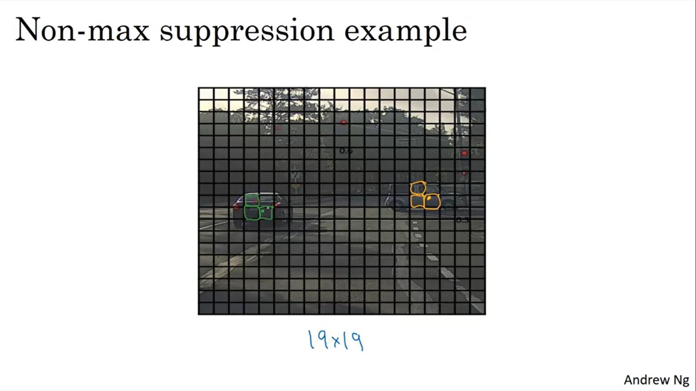

Maybe all the marked boxes found a car.

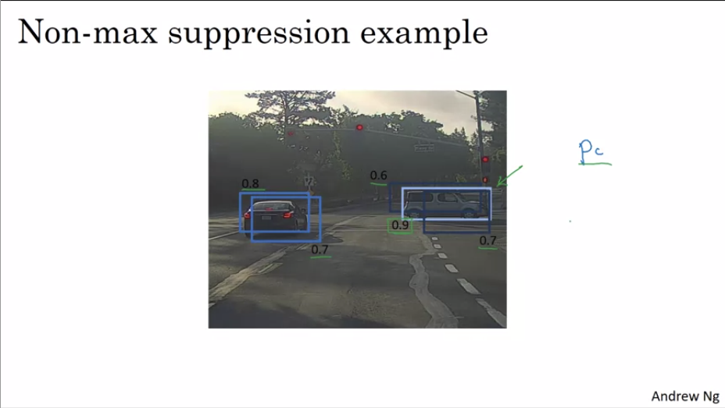

Non-max suppression cleans up these duplicate detections.

It first looks at the probabilities for detection and will take the highest one. Then it looks at all the remaining rectangles and the ones with a high IoU with the highest prob rectangle will be supressed.

The dark rectangles (right car) will be suppressed here.

Then you go through the still remaining rectangles and follow the same process.

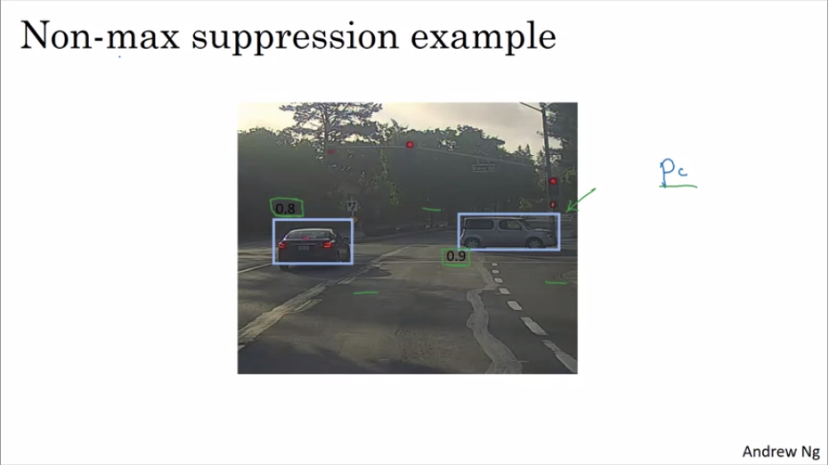

You will be left with just the highlighted rectangles.

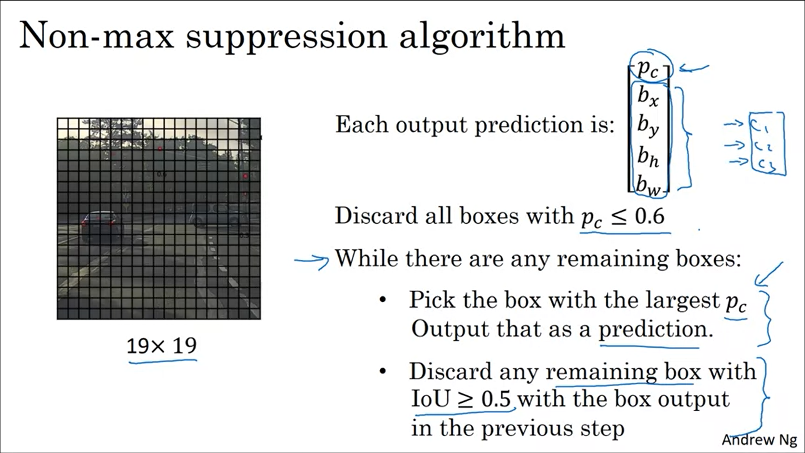

Now we will assume we are just looking for cars so we will have output vectors of length 5 (the c’s are not needed anymore).

If you are trying to detect multiple objects, you should carry out non-max suppression independently for each object class.



One more idea that makes the algorithm work much better.

One of the problems with object detection seen so far is that each grid cell can only output 1 object. What if a grid cell wants to output multiple objects? We can use the idea of anchor boxes.

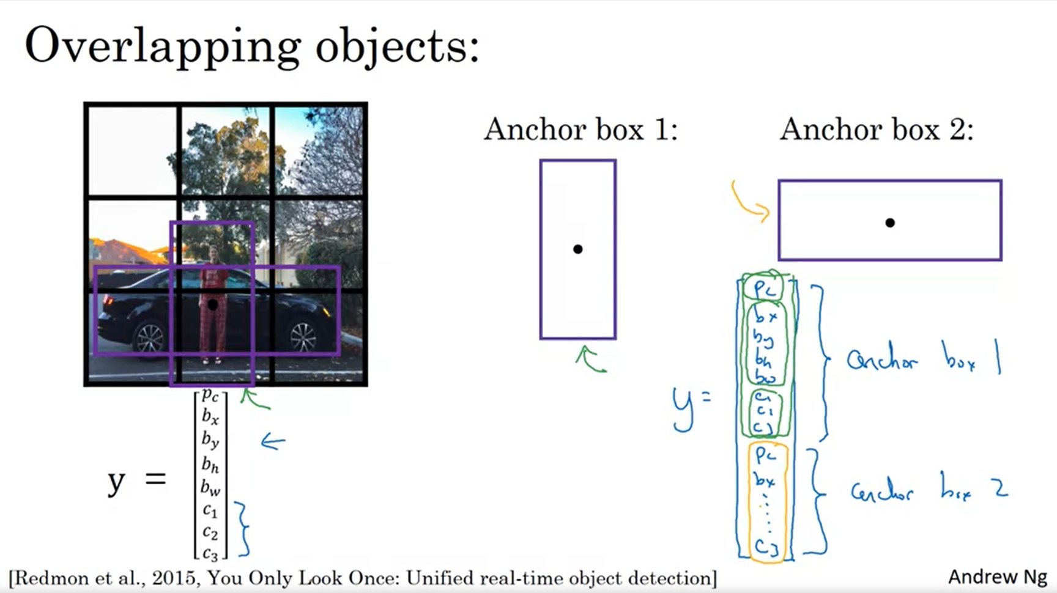

We will predefine two anchor box shapes. In general, you can define more anchor boxes, e.g. 5.

Repeat the class label twice (for each anchor box).

Always use the anchor box that is more similar to the object that you want to label. For example, the shape of the pedestrian is more similar to anchor box 1.

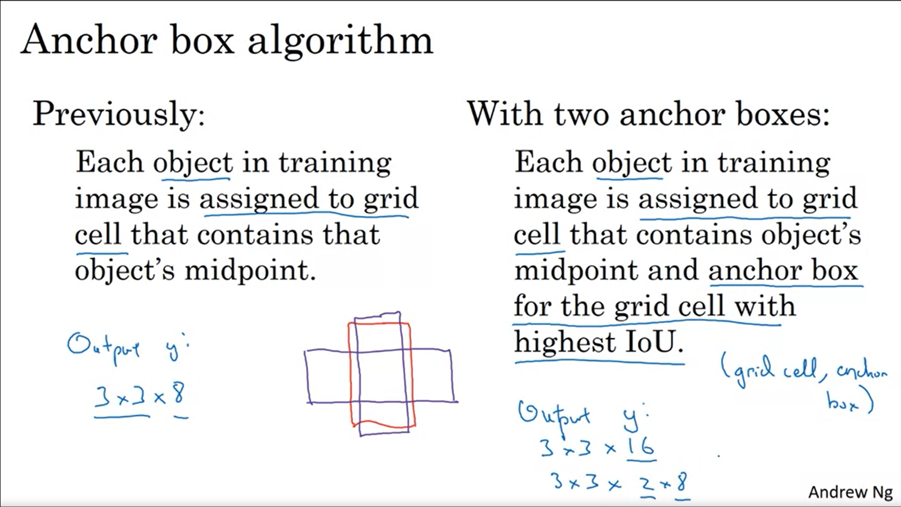

Each object gets assigned to a grid cell – anchor box pair.

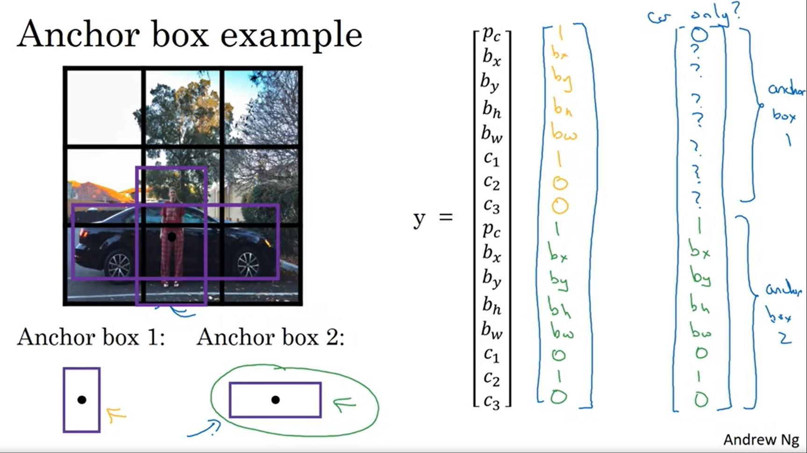

If you have two anchor boxes but 3 objects in the grid cell, then this algorithm will not handle it well.

Andrew would just implement a default tie breaker.

Or what if your objects have the same anchor box shape? That is another case that the algorithm does not handle well. But usually it does not happen often. We need some default tie breaker here as well.

In practice it happens quite rarely that two objects appear in the same grid cell (aka have their midpoint in the same grid cell).

But: anchor boxes also help the learning algorithm to specialize better, in particular if the dataset has some tall and some wide objects. The output units can specialize.

People choose the anchor box shapes often by hand. An even better way to do this is use k-means to group together the kind of objects that you get and then select an anchor box that is most stereotypically representative of the object classes that you want to detect.



Let’s put all the components together.

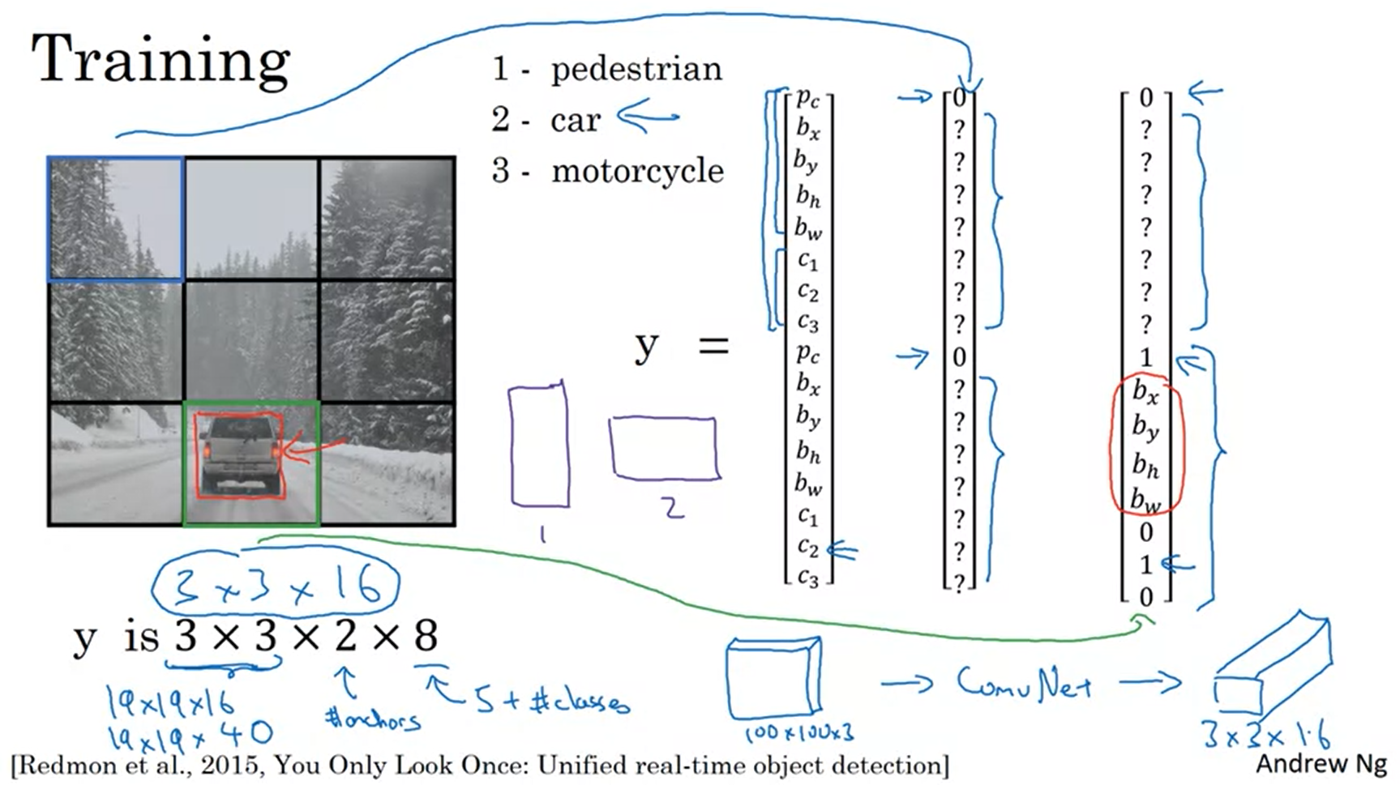

First: create the training set. Form the appropriate anchor box target vector for each grid cell, then put them together into a volume.

Most of the grid cells have nothing in them.

The red box has slightly higher IoU with anchor box 2.

With 15 anchor boxes and a 19x19 grid the output volume would be 19x19x40.

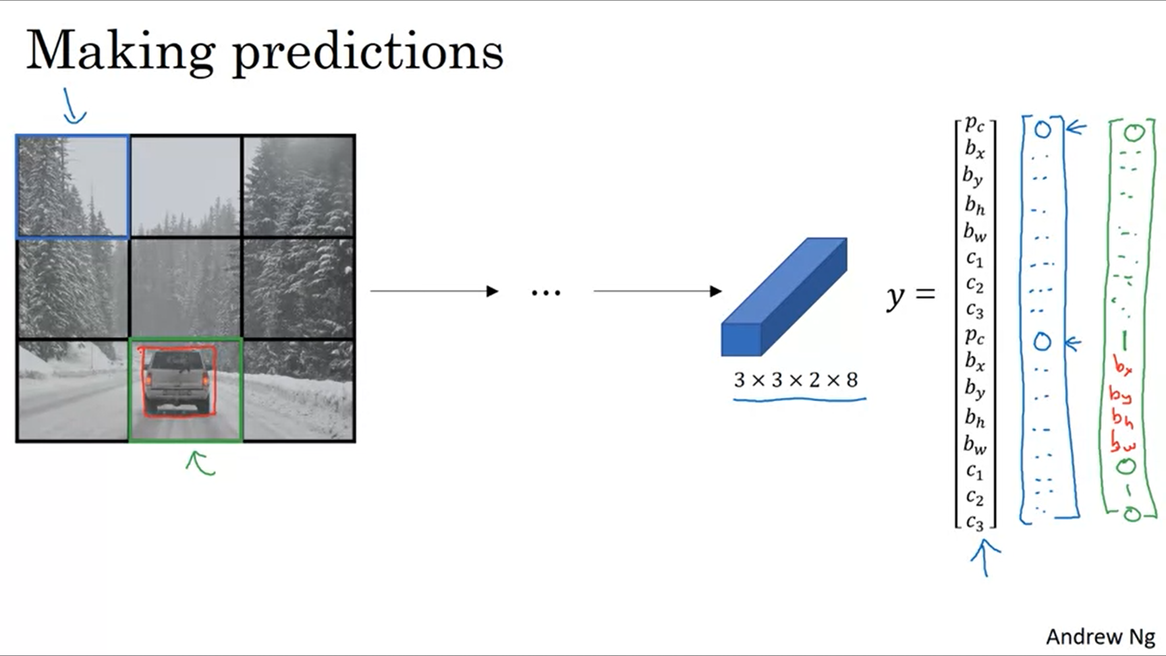

How can the algorithm make predictions?

The algorithm will output some numbers for the question marks but these will just be ignored (just noise).

Hopefully the output for the middle bottom cell will look like the green vector.

Finally you would run this through non-max suppression.

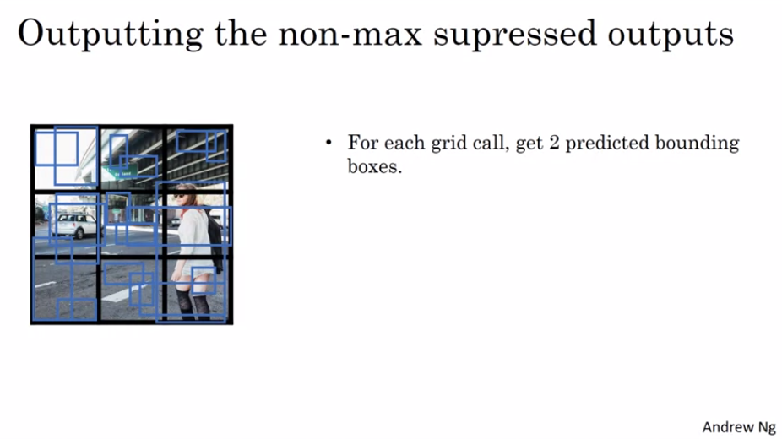

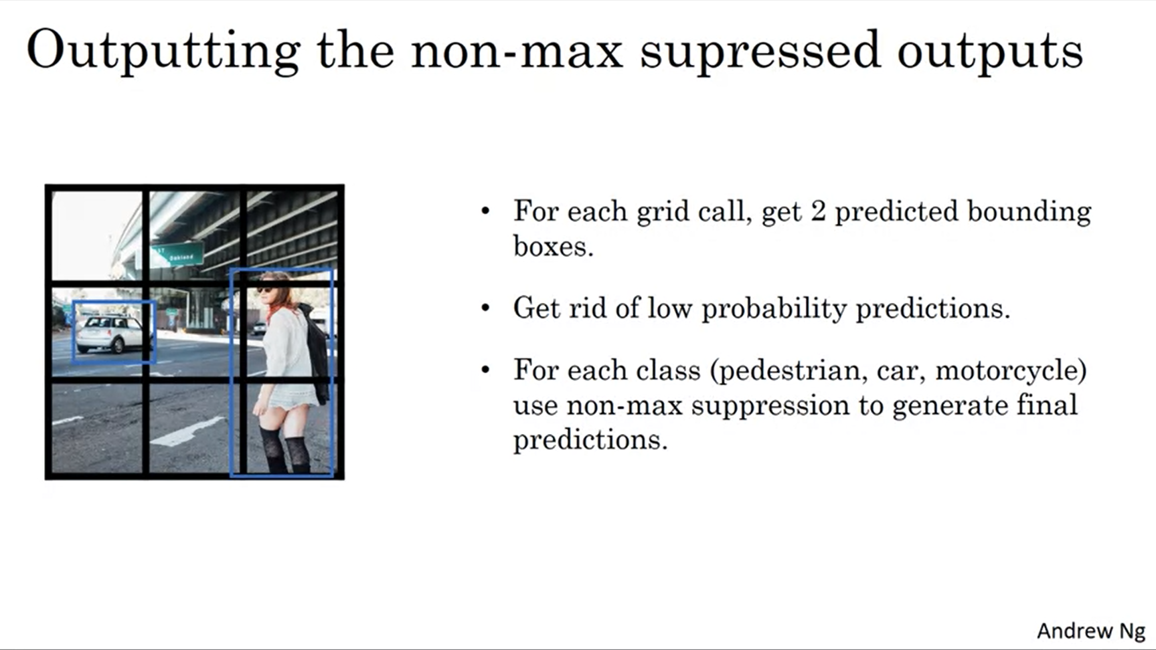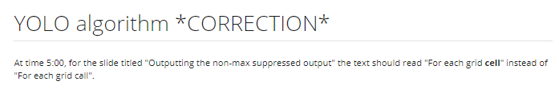

Yolo is one of the most effective object detection algorithms that also encompasses many of the best ideas from the computer vision community regarding object detection.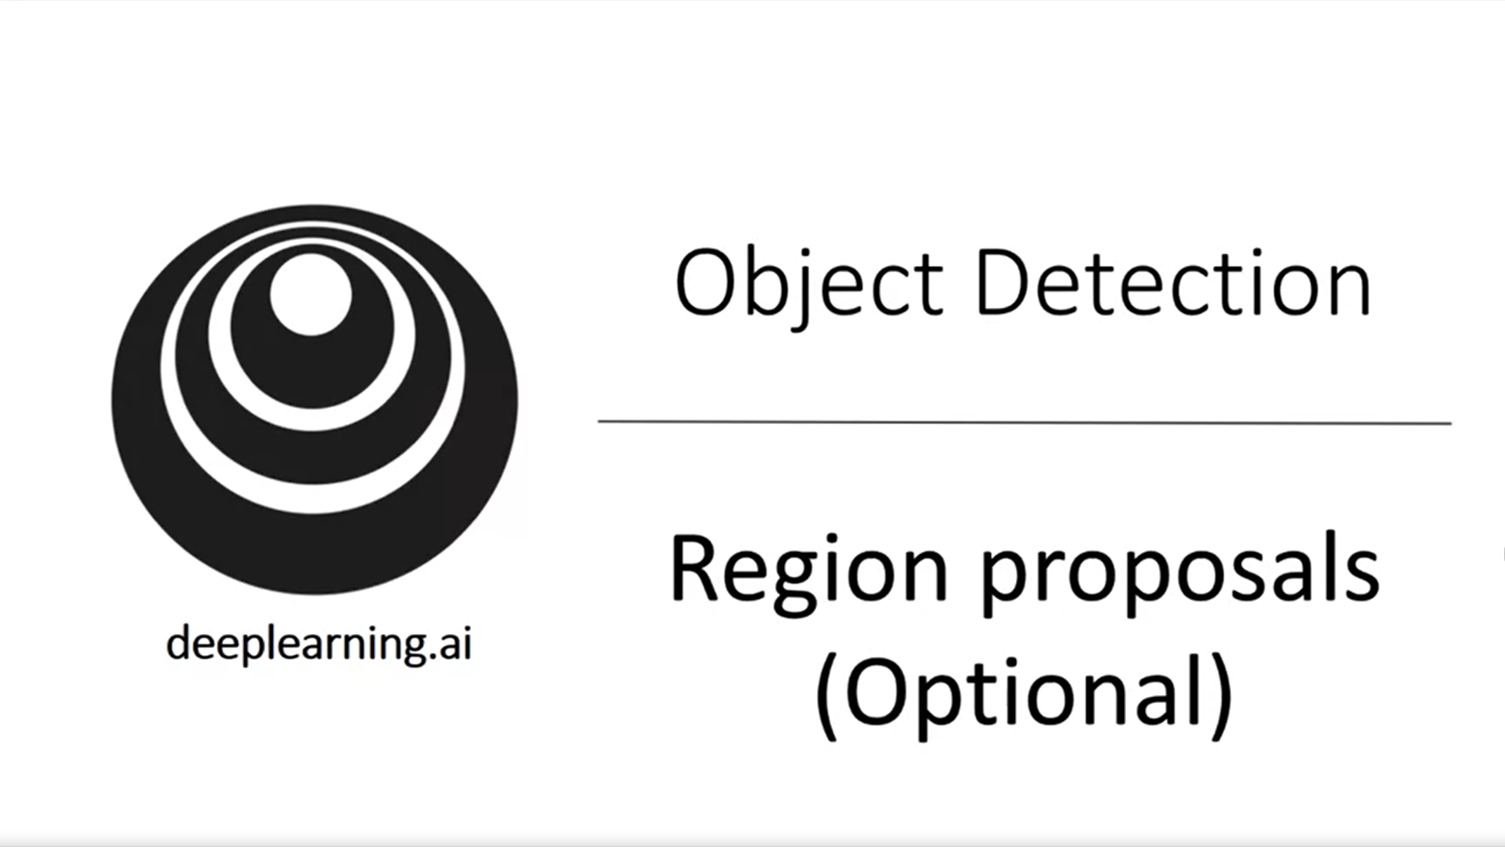

If you look at the object detection literature there is a set of ideas called region proposals. Andrew tends to use these a little less often. That is why the video is optional.

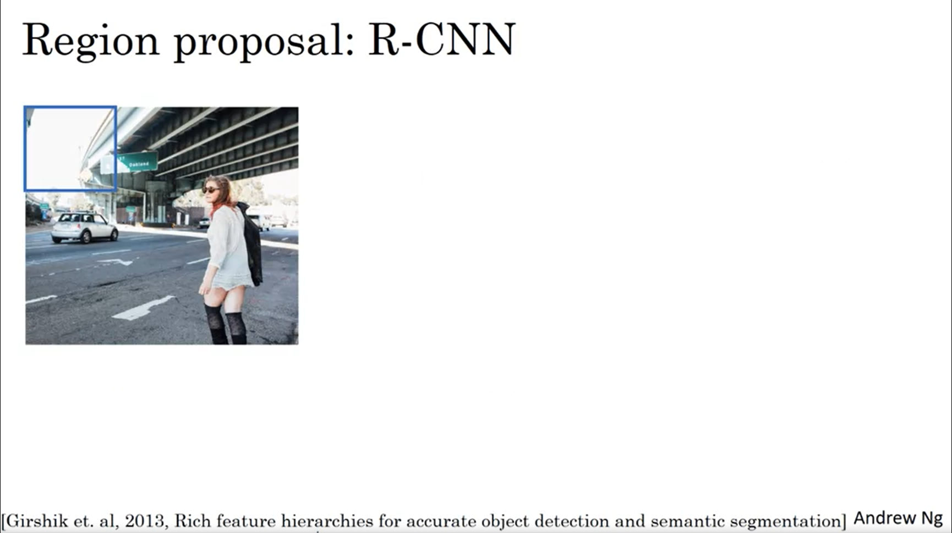

Recall the sliding windows idea.

One of the downsides of the algorithm is that it just classifies a lot of regions where there is clearly no object.

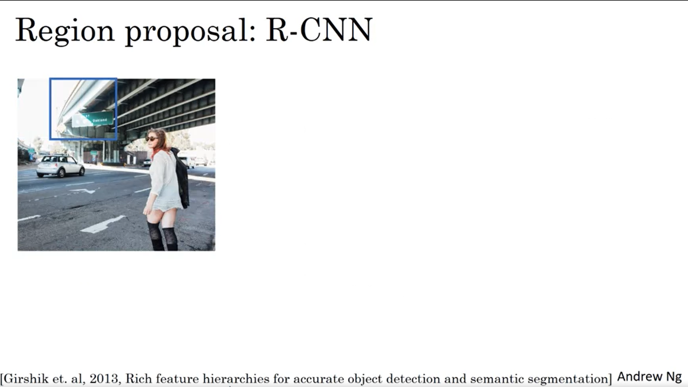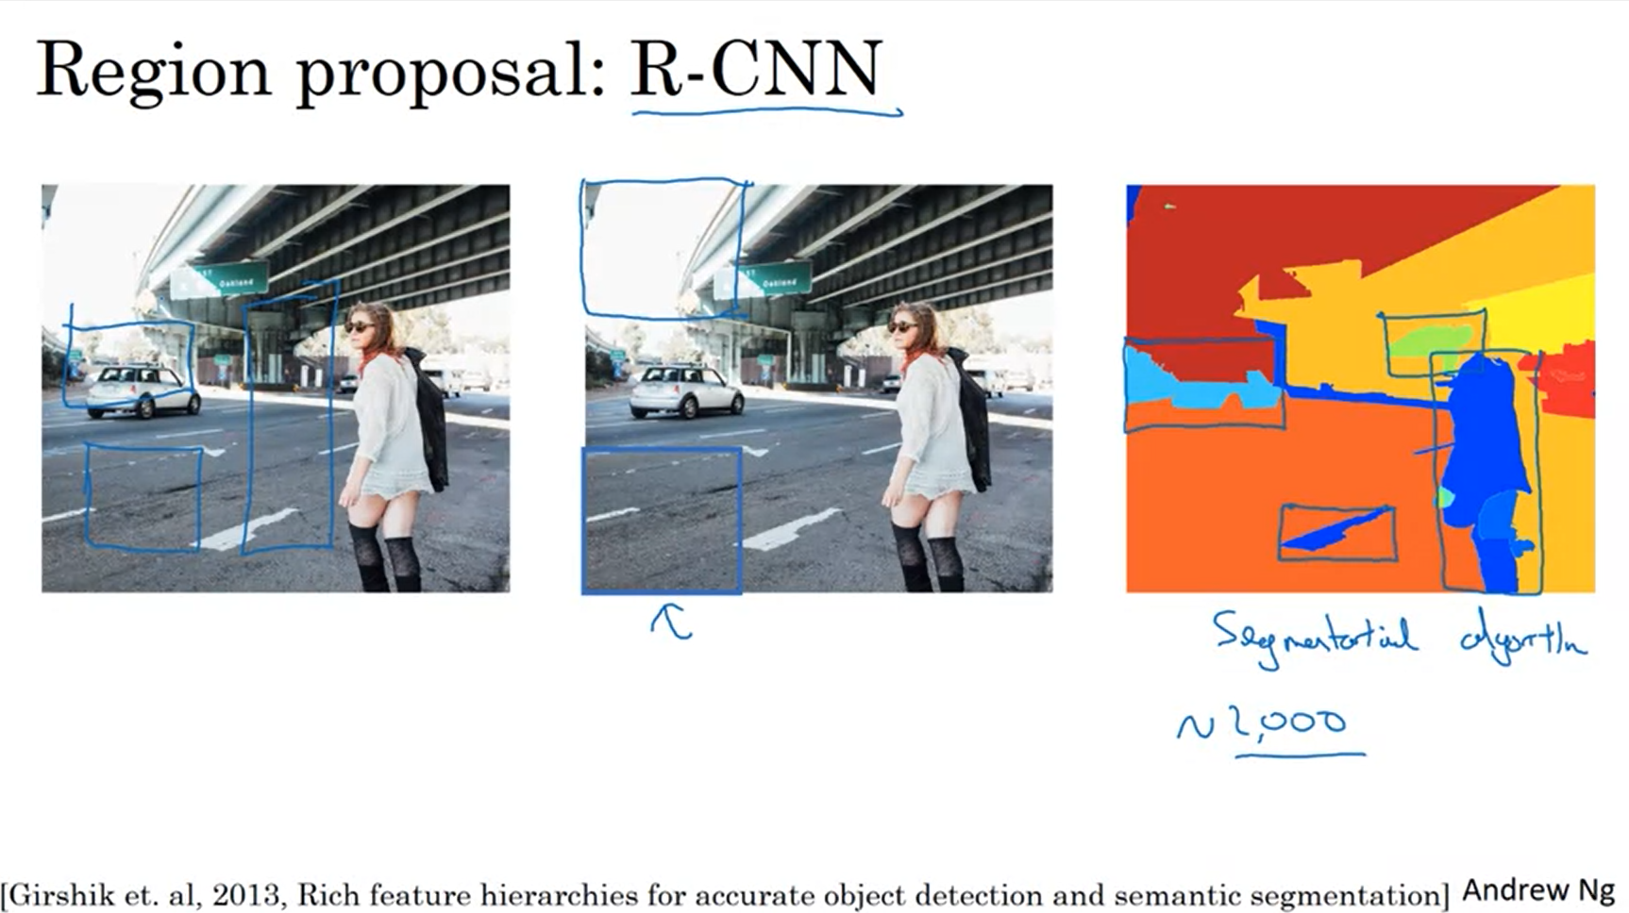

There is an algorithm called Regions-CNN which just picks a few regions on which it makes sense to run the CNN classifier on (instead of every window of the sliding window algorithm).

There is a segmentation algorithm which tries to find potential objects.

Only run the classifier on the “blobs” found by this segmentation algorithm.

For example: find 2000 blobs and run classifier on these 2000 blobs. This can be a much smaller number of positions than to run it on every single position in the image with different sizes.

The algorithm is still quite slow though. So there have been proposals to make it faster.

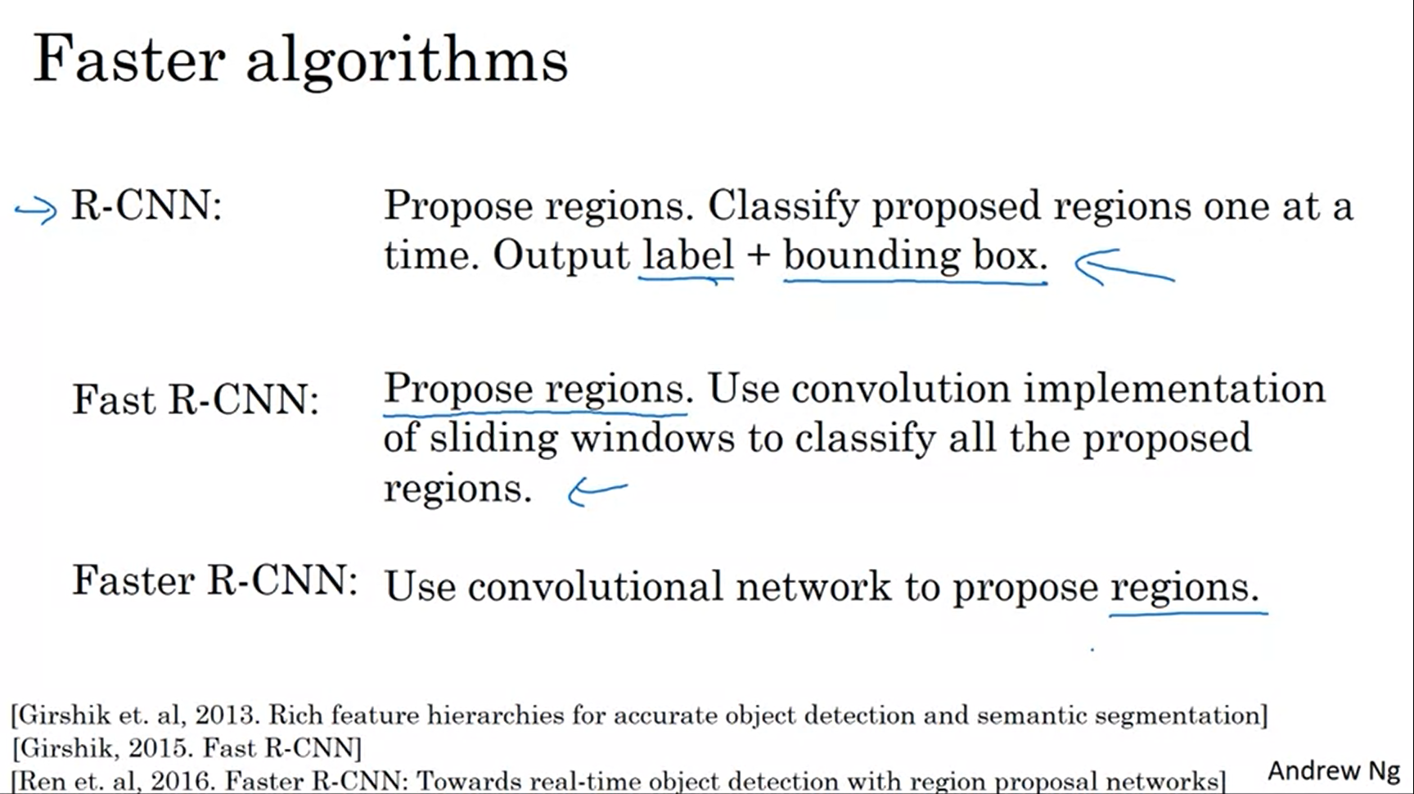

The R-CNN does not trust the given bounding box but tries to output a more accurate bounding box.

Problem with Fast R-CNN: the clustering step to propose the regions is still quite slow. This can be sped up using convnets.

The Faster R-CNN algorithm is still way slower than the YOLO algorithm.

Andrew’s personal opinion is that he prefers doing everything in 1 step like YOLO (also from a long-term perspective).